**VIVEKANAND EDUCATION SOCIETY’S INSTITUTE OF TECHNOLOGY**

**An Autonomous Institute Affiliated to University of Mumbai**

**Department of Computer Engineering**



|  |
| --- |

Project Report on

**EcoRestore : An Intelligent Zone Identification for Reforestation**

In partial fulfillment of

Bachelor of Engineering (B.E.) Course in Computer Engineering at the University of Mumbai Academic Year 2024-25

**Submitted by**

Vaishnavi Chavan (D17B-9)

Akash Fatnani (D17B-12)

Shreya Nalawade(D17B-34)

Gayatri Vaidya(D17B-60)

**Project Mentor**

Dr. Prashant Kanade

(2024-25)

**VIVEKANAND EDUCATION SOCIETY’S INSTITUTE OF TECHNOLOGY**

**An Autonomous Institute Affiliated to University of Mumbai**

**Department of Computer Engineering**



**Certificate**

This is to certify that ***Vaishnavi Chavan, Akash Fatnani, Shreya Nalawade, Gayatri Vaidya*** of Fourth Year Computer Engineering studying under the University of Mumbai have satisfactorily completed the project on “**EcoRestore : Intelligent Zone Identification for Reforestation**” as a part of their coursework of PROJECT-II for Semester-VIII under the guidance of their mentor ***Prof. Dr. Prashant Kanade*** in the year 2024-25 .

This thesis/dissertation/project report entitled (**EcoRestore : Intelligent Zone Identification for Reforestation**) by (***Prof. Dr. Prashant Kanade***) is approved for the degree of ***Computer Engineering*** (***Degree details***).

| Programme Outcomes | Grade |
| --- | --- |
| PO1,PO2,PO3,PO4,PO5,PO6,PO7,  PO8, PO9, PO10, PO11, PO12  PSO1, PSO2 |  |

Date:

Project Guide:

------------------------------------------

Dr Prashant Kanade

**Project Report Approval**

**For**

**B. E (Computer Engineering)**

This thesis/dissertation/project report entitled (**EcoRestore : Intelligent Zone Identification for Reforestation**) by (***Prof. Dr. Prashant Kanade***) is approved for the degree of ***Computer Engineering*** (***Degree details***).

Internal Examiner

---------------------------------------------

External Examiner

---------------------------------------------

Head of the Department

-----------------------------------------------

Principal

-----------------------------------------------

Date:

Place:

**Declaration**

We declare that this written submission represents our ideas in our own words and where others' ideas or words have been included, we have adequately cited and referenced the original sources. We also declare that we have adhered to all principles of academic honesty and integrity and have not misrepresented or fabricated or falsified any idea/data/fact/source in our submission. We understand that any violation of the above will be cause for disciplinary action by the Institute and can also evoke penal action from the sources which have thus not been properly cited or from whom proper permission has not been taken when needed.

| -----------------------------------------  (Signature)  Vaishnavi Chavan (D17B-9) | -----------------------------------------  (Signature)  Akash Fatnani (D17B-12) |
| --- | --- |
| -----------------------------------------  (Signature)  Shreya Nalawade (D17B-34) | -----------------------------------------  (Signature)  Gayatri Vaidya (D17B-60) |

Date:

**ACKNOWLEDGEMENT**

We are thankful to our college Vivekanand Education Society’s Institute of Technology for considering our project and extending help at all stages needed during our work of collecting information regarding the project.

It gives us immense pleasure to express our deep and sincere gratitude to Assistant Professor **Dr. Prashant Kanade** for his kind help and valuable advice during the development of project synopsis and for his guidance and suggestions.

We are deeply indebted to Head of the Computer Department **Dr.(Mrs.) Nupur Giri** and our Principal **Dr. (Mrs.) J.M. Nair ,** for giving us this valuable opportunity to do this project.

We express our hearty thanks to them for their assistance without which it would have been difficult in finishing this project synopsis and project review successfully.

We convey our deep sense of gratitude to all teaching and non-teaching staff for their constant encouragement, support and selfless help throughout the project work. It is a great pleasure to acknowledge the help and suggestion, which we received from the Department of Computer Engineering.

We wish to express our profound thanks to all those who helped us in gathering information about the project. Our families too have provided moral support and encouragement several times.

**Computer Engineering Department**

**COURSE OUTCOMES FOR B.E PROJECT**

Learners will be to,

| **Course Outcome** | **Description of the Course Outcome** |
| --- | --- |
| CO 1 | Able to apply the relevant engineering concepts, knowledge and skills towards the project. |
| CO2 | Able to identify, formulate and interpret the various relevant research papers and to determine the problem. |
| CO 3 | Able to apply the engineering concepts towards designing solutions for the problem. |
| CO 4 | Able to interpret the data and datasets to be utilized. |
| CO 5 | Able to create, select and apply appropriate technologies, techniques, resources and tools for the project. |
| CO 6 | Able to apply ethical, professional policies and principles towards societal, environmental, safety and cultural benefit. |
| CO 7 | Able to function effectively as an individual, and as a member of a team, allocating roles with clear lines of responsibility and accountability. |
| CO 8 | Able to write effective reports, design documents and make effective presentations. |
| CO 9 | Able to apply engineering and management principles to the project as a team member. |
| CO 10 | Able to apply the project domain knowledge to sharpen one’s competency. |
| CO 11 | Able to develop professional, presentational, balanced and structured approach towards project development. |
| CO 12 | Able to adopt skills, languages, environment and platforms for creating innovative solutions for the project. |

**List Of Figures**

| Fig No | Title | Page No |
| --- | --- | --- |
| 1. | Block Diagram of the system | 32 |
| 2. | Modular Diagram | 34 |
| 3. | Detailed Diagram | 37 |
| 4. | Gantt chart | 39 |
| 5. | Flowchart for Random forest classifier | 44 |
| 6. | Flowchart for soil classification module | 48 |
| 7. | Flowchart for landcover classification using CNN | 52 |
| 8. | UI for EcoRestore | 59 |
| 9. | UI for Crop Recommendation system | 60 |
| 10. | UI for RGB Visualization | 60 |
| 11. | Streamlit UI for landcover classficaition | 61 |
| 12. | UI for soil classification | 61 |
| 13. | Crop Recommendation results | 67 |
| 14. | Confusion Matrix for crop recommendation | 68 |
| 15. | Epoch vs Accuracy | 68 |
| 16. | Test accuracy for soil classification | 69 |
| 17. | Landcover classification for Thane creek area | 69 |
| 18. | Landcover classification for Panvel | 69 |
| 19. | Analysis for Landcover classification | 70 |
| 20. | Confusion matrix for landcover classification | 70 |

**List Of Tables**

| Table No | Table Title | Page No. |
| --- | --- | --- |
| Table 1 | Traditional Systems vs Modern GEE-based ML Systems | 25 |
| Table 2 | Hardware Requirements | 29 |
| Table 3 | Software Requirements | 30 |
| Table 4 | Tools used | 30 |
| Table 5 | Crop recommendation module test case | 57 |
| Table 6 | Soil classification module test case | 57 |
| Table 7 | Satellite image classification module test case | 57 |

**Index**

**Title page no.**

**Abstract……………………………………………………………………….11**

**Chapter 1: Introduction**

1.1 Introduction ………………………………………………………………..12

1.2 Motivation………………………………………………………………….12

1.3 Problem Definition…………………………………………………………13

1.4 Existing Systems …………………………………………………………..14

1.5 Lacuna of the existing systems …………………………………………….14

1.6 Relevance of the Project……………………………………………………14

**Chapter 2: Literature Survey**

A. Brief Overview of Literature Survey………………………………………..16

B. Related Works

2.1 Research Papers Referred………………………………………………… .17

a. Abstract of the research paper

b. Inference drawn

2.2 Patent search ……………………………………………………………….23

Links 1. European Patent

2. US patent

2.3. Inference drawn…………………………………………………………….23

2.4 Comparison with the existing system……………………………………….24

**Chapter 3: Requirement Gathering for the Proposed System**

3.1 Introduction to requirement gathering ……………………………………...26

3.2 Functional Requirements……………………………………………………27

3.3 Non-Functional Requirements………………………………………………28

3.4.Hardware, Software , Technology and tools utilized……………………….29

3.5 Constraints…………………………………………………………………..30

**Chapter** 4**: Proposed Design**

4.1 Block diagram of the system ……………………………………………….32

4.2 Modular design of the system ………………………………………………34

4.3 Detailed Design…………………………………………………………….37

4.4 Project Scheduling & Tracking using Timeline / Gantt Chart ……………..39

**Chapter 5: Implementation of the Proposed System**

5.1. Methodology employed for development …………………………………41

5.2 Algorithms and flowcharts for the respective modules developed………..42

5.3 Datasets source and utilization……………………………………………..53

**Chapter 6: Testing of the Proposed System**

6.1 . Introduction to testing ……………………………………………………..56

6.2. Types of tests Considered…………………………………………………..56

6.3 Various test case scenarios considered ……………………………………...57

6.4. Inference drawn from the test cases…………………………………………58

**Chapter 7: Results and Discussion**

7.1. Screenshots of User Interface (UI) for the respective module ………………59

7.2. Performance Evaluation measures …………………………………………..62

7.3. Input Parameters / Features considered………………………………………64

7.4. Graphical and statistical output ………………………………………………66

7.5. Inference drawn……………………………………………………………….69

**Chapter 8: Conclusion**

8.1 Limitations……………………………………………………………………..71

8.2 Conclusion……………………………………………………………………..72

8.3 Future Scope……………………………………………………………………73

**References**

**Appendix**

**1. Paper I & II Details**

1. Paper published
2. Certificate of publication
3. Plagiarism report
4. Project review sheet

**2. Competition certificates**

**Abstract**

Environmental sustainability and effective land management have become increasingly critical in the face of climate change and population growth. To address these challenges, the project titled EcoRestore: Intelligent Identification of Reforestation Zones integrates machine learning, remote sensing, and deep learning techniques to facilitate reforestation planning and crop recommendation.

The project is structured into three core components. The first involves a crop recommendation system built using a Random Forest Classifier. This model analyzes various agricultural parameters—such as soil nutrients (nitrogen, phosphorus), pH, temperature, humidity, and rainfall—to suggest the most suitable crops for cultivation. By leveraging historical data, the system aims to support data-driven agricultural decision-making.

The second component focuses on soil classification through the use of a Convolutional Neural Network (CNN). Soil images categorized into red, black, clay, and alluvial types are used to train the model. This classification helps refine the crop recommendation by providing insights into the land’s physical properties.

The third component utilizes Google Earth Engine (GEE) to access and process multi-temporal satellite imagery. Landsat-8 data and various vegetation indices (such as NDVI, EVI, and NDBI) are employed to classify land cover and detect degraded or deforested areas. A CNN model then identifies potential zones for reforestation by categorizing terrain into classes like forest, barren land, water bodies, and built-up regions.

Collectively, these modules form a cohesive system capable of supporting sustainable land use planning. The integration of AI with satellite data not only enhances ecological analysis but also empowers agricultural and environmental stakeholders with actionable insights. EcoRestore demonstrates how modern technology can be effectively utilized to support both agricultural productivity and environmental restoration efforts.

1. **Introduction**

**1.1 Introduction**

Deforestation refers to the widespread clearing of forests, often for agriculture, infrastructure, or urban expansion.This large-scale loss of forest cover significantly reduces the planet’s ability to sequester carbon dioxide, a key greenhouse gas.With fewer trees to absorb CO₂, its concentration in the atmosphere rises sharply, amplifying the greenhouse effect.As a result, deforestation accelerates global warming, disrupts weather patterns, and contributes to climate instability.Beyond climate impact, deforestation also threatens biodiversity, disrupts ecosystems, and affects local livelihoods. Despite significant advancements in satellite-based land assessment and crop recommendation models, existing solutions lack automation, scalability, and intelligent decision-making capabilities. Traditional survey-based land assessment methods remain inefficient, labor-intensive, and unsuitable for large-scale evaluations. Moreover, current approaches do not effectively integrate artificial intelligence-driven techniques to analyze soil properties, climate conditions, and satellite imagery, leading to fragmented and suboptimal decision-making in reforestation planning. Conventional models primarily rely on statistical heuristics rather than deep learning-based predictive analytics, limiting their adaptability and accuracy in diverse environmental conditions. Additionally, existing land cover classification methods often employ generalized techniques that fail to incorporate real-time adaptability and precision, reducing their effectiveness in identifying suitable reforestation zones. To overcome these limitations, an automated decision-support system that leverages deep learning and AI-driven integration is required for accurate land evaluation and reforestation planning.

**1.2 Motivation**

Reforestation plays a critical role in addressing climate change, biodiversity conservation, and soil degradation. However, increasing rates of deforestation, unsustainable land management practices, and environmental degradation have made the restoration of ecosystems an urgent priority. Traditional land assessment methods rely heavily on manual surveys and empirical models, which are often time-consuming, labor-intensive, and prone to inaccuracies. To achieve scalable and efficient ecological restoration, advanced technologies such as machine learning (ML) and deep learning (DL) must be integrated into environmental planning and decision-making.

Artificial Intelligence (AI) has shown significant potential in environmental sustainability and ecological restoration by enabling data-driven decision-making, predictive analytics, and real-time monitoring. The application of ML and DL in ecological research allows for the accurate identification of land suitability for reforestation, crop recommendations, and soil classification. Moreover, the utilization of remote sensing and satellite imagery analysis enhances large-scale land monitoring, enabling more effective reforestation planning.

**1.3 Problem Definition**

Despite significant advancements in satellite-based land assessment and crop recommendation models, existing solutions lack automation, scalability, and intelligent decision-making capabilities. Traditional survey-based land assessment methods remain inefficient, labor-intensive, and unsuitable for large-scale evaluations. Moreover, current approaches do not effectively integrate artificial intelligence-driven techniques to analyze soil properties, climate conditions, and satellite imagery, leading to fragmented and suboptimal decision-making in reforestation planning. Conventional models primarily rely on statistical heuristics rather than deep learning-based predictive analytics, limiting their adaptability and accuracy in diverse environmental conditions. Additionally, existing land cover classification methods often employ generalized techniques that fail to incorporate real-time adaptability and precision, reducing their effectiveness in identifying suitable reforestation zones. To overcome these limitations, an automated decision-support system that leverages deep learning and AI-driven integration is required for accurate land evaluation and reforestation planning.

**1.4 Existing Systems**

Remote sensing and machine learning technologies have been widely adopted in recent years for land cover classification, soil analysis, and crop recommendation. Current systems utilize platforms like Google Earth Engine (GEE), which provides a cloud-based environment for analyzing geospatial data, enabling large-scale environmental monitoring.

Several existing systems are built upon satellite imagery from Sentinel-2 and Landsat-8, integrated with machine learning models such as Random Forest (RF) and Support Vector Machines (SVM) for classifying land use types like vegetation, water bodies, and urban areas. These methods have proven effective in extracting features from multispectral data but may face challenges in handling complex landscape variations.

Deep learning-based systems, particularly those using Convolutional Neural Networks (CNNs), have emerged as alternatives to traditional ML models, offering improved accuracy in land classification and soil type detection. These systems leverage hyperspectral and multispectral imagery to identify subtle patterns in the data that are often missed by conventional techniques.

For agricultural applications, crop recommendation systems are typically built using machine learning algorithms that analyze factors such as soil nutrients, past yield data, and climatic variables. These systems help farmers make informed decisions about which crops are best suited for specific regions.

Despite their effectiveness, existing systems often operate in silos—land classification, soil analysis, and crop recommendation are frequently handled by separate models. Moreover, these systems may require substantial computational resources or localized datasets, limiting scalability and generalizability across regions.

Thus, while existing systems demonstrate the potential of combining GEE with machine learning and deep learning, there remains a need for a unified, scalable framework that integrates land classification, soil analysis, and crop recommendation into a single, efficient pipeline to support sustainable land use planning and reforestation efforts.

**1.5 Lacuna of the existing systems**

**Data Gaps:**Many areas lack high-resolution, cloud-free imagery, making accurate analysis difficult.

**Limited Multi-Source Use:**Most approaches rely only on satellite data, overlooking valuable inputs from LiDAR, climate models, and field surveys.

**AI Underutilization:**Advanced AI techniques, such as deep learning applied to time-series data, are rarely used for dynamic monitoring.

**Ground Truth Shortage:**On-ground verification is limited, particularly in remote and inaccessible forest regions.

**Socio-Economic Blind Spot:**  
Maps often miss local socio-economic factors, including community land rights, economic pressures, and governance dynamics.

**Static Maps:**Most existing outputs are static maps with no real-time updates, reducing their relevance for continuous monitoring and policy action.

**1.6 Relevance of the Project**

The EcoRestore system addresses a critical global challenge: the urgent need for scalable and intelligent reforestation planning in the face of climate change, land degradation, and biodiversity loss. Traditional approaches to land evaluation and ecological planning rely heavily on manual processes and statistical models, which are insufficient for large-scale, real-time applications. This project introduces a comprehensive, AI-driven solution that integrates crop recommendation, soil classification, and satellite-based land cover analysis into a unified decision-support framework.

With the growing availability of remote sensing data and advancements in machine learning, EcoRestore stands at the intersection of agriculture, environmental sustainability, and artificial intelligence, offering a transformative approach to land management. Its relevance is highlighted by the following contributions:

* Automation of Ecological Assessment: By replacing manual and heuristic-based methods with machine learning and deep learning models, EcoRestore provides automated, accurate, and fast evaluations of soil types, crop suitability, and land cover classification.
* Multi-layered Intelligence: The integration of CNN for soil classification, Random Forest for crop recommendation, and deep learning with GEE for satellite image analysis allows for a holistic understanding of the landscape, ensuring informed and sustainable ecological decisions.
* Scalability and Real-world Applicability: Designed for scalability, EcoRestore leverages cloud-based platforms like Google Earth Engine, making it adaptable for diverse geographical areas and suitable for large-scale reforestation initiatives.
* Support for Precision Agriculture: Through soil-specific crop recommendation and climate-aware prediction models, the project aligns with the goals of precision agriculture, promoting sustainable land use and increased agricultural productivity.
* Sustainability and SDG Alignment: The system contributes directly to the United Nations Sustainable Development Goals (SDGs), particularly SDG 13 (Climate Action), SDG 15 (Life on Land), and SDG 2 (Zero Hunger), by fostering sustainable land management and environmental resilience.

1. **Literature Survey**
2. **Overview of Literature survey:**

Land Use and Land Cover (LULC) classification is essential for identifying reforestation zones, monitoring environmental changes, and enabling sustainable land planning. With the rise of satellite imagery from platforms like Landsat-8 and Sentinel-2, remote sensing has become a powerful tool for large-scale land assessment. Cloud-based platforms such as Google Earth Engine (GEE) support the processing of vast geospatial datasets efficiently. Machine learning algorithms like Random Forest (RF), Support Vector Machine (SVM), and CART have been widely used for classifying land cover types. Additionally, deep learning methods, especially Convolutional Neural Networks (CNN), offer improved accuracy in image-based classification. These methods help distinguish between forests, croplands, barren lands, and urban areas. The integration of temporal and spectral data has further enhanced model performance.

Recent studies emphasize combining spectral indices like NDVI, EVI, and NDBI with other spatial features to improve classification precision. Hybrid approaches that merge satellite imagery with AI models show promising results for ecological applications. The literature suggests that traditional manual assessments are being replaced by automated, scalable systems. This shift supports timely and accurate decision-making for environmental restoration. Our project, EcoRestore, aligns with these advancements by integrating ML, CNN, and GEE for reforestation planning. It builds on past research to deliver an intelligent, AI-powered solution for sustainable land use.

1. **Related Works:**

Several studies have applied machine learning for crop recommendation using parameters like soil nutrients, temperature, and rainfall. Random Forest and Decision Tree models are commonly used due to their accuracy and interpretability. Similarly, **CNN-based** models have proven effective in classifying soil types from image datasets, aiding in precise agricultural planning.

In the area of land cover classification, satellite imagery processed using platforms like **Google Earth Engine (GEE)** is widely used. Vegetation indices such as NDVI and EVI help identify deforested or degraded regions. While earlier works focused on individual components, our project integrates all three—crop recommendation, soil classification, and reforestation zone detection—into a single AI-driven system for sustainable land use.

**2.1 Research Papers Referred:**

A variety of research papers were studied to understand the effectiveness of **Google Earth Engine (GEE)** for land use and land cover (LULC) classification. These papers covered global and regional studies, demonstrating that GEE, when combined with machine learning algorithms like Random Forest, SVM, and CART, delivers high accuracy in LULC classification. Researchers used data from platforms such as Landsat-8, Sentinel-1/2, MODIS, and NAIP, achieving accuracies ranging from 80% to 98%. Many studies reported that Random Forest outperformed other models, and the GEE Python API was found to be efficient and time-saving.

Overall, the studies confirm that GEE is a reliable, scalable, and accessible tool for automated and high-accuracy land cover classification. It also supports decision-making for environmental monitoring by offering cloud-based processing power and integrating diverse satellite data sources.

**1. Title: Google Earth Engine for Advanced Land Cover Analysis from Landsat-8 Data with Spectral and Topographic Insights**

**Citation** : A. Abdollahi, B. Pradhan, A. Alamri, and C.-W. Lee, "Google Earth Engine for Advanced Land Cover Analysis from Landsat-8 Data with Spectral and Topographic Insights," J. Sens., vol. 2023, Art. no. 6657171, Oct. 2023. doi: [10.1155/2023/6657171](https://doi.org/10.1155/2023/6657171).

**Abstract summary**: Google Earth Engine can be used effectively to classify land cover from Landsat-8 data using spectral and topographic features.

**Main findings**: - The SVM classification approach, using Landsat-8 multitemporal data, spectral indices, and topographic components, achieved high overall accuracy (92.90%) and kappa accuracy (90.99%) for land cover mapping.

- Landsat-8 multitemporal data, spectral indices, topographic components, and postprocessing techniques were all important factors in producing high-quality land cover maps.

- The use of the freely accessible GEE platform and Landsat-8 multitemporal data provides decision-makers with the resources to effectively track land cover changes throughout the year.

**2. Title: Utilization of Google Earth Engine (GEE) for land cover monitoring over Klang Valley, Malaysia**

**Citations**: N. A. Wahap and H. Z. M. Shafri, "Utilization of Google Earth Engine (GEE) for Land Cover Monitoring over Klang Valley, Malaysia," IOP Conference Series: Earth and Environmental Science, vol. 540, no. 1, p. 012003, July 2020. doi: 10.1088/1755-1315/540/1/012003.

**Abstract summary :** The paper demonstrates the feasibility of using Google Earth Engine for land cover monitoring and classification in the Klang Valley, Malaysia.

**Main findings:**

- The CART machine learning algorithm showed the highest classification accuracy (94.71%, 97.72%, 96.57%) compared to RF and SVM when classifying land cover in the Klang Valley area over 1988, 2003, and 2018.

- Some misclassification errors occurred due to the way the satellite image composites were created, without accounting for crop phenological stages.

**3. Title : Mapping the Land Cover of Africa at 10 m Resolution from Multi-Source Remote Sensing Data with Google Earth Engine**

**Citation:** Q. Li, C. Qiu, L. Ma, M. Schmitt, and X. X. Zhu, "Mapping the Land Cover of Africa at 10 m Resolution from Multi-Source Remote Sensing Data with Google Earth Engine," Remote Sensing, vol. 12, no. 4, p. 602, Feb. 2020. doi: 10.3390/rs12040602.

**Abstract summary** : This paper presents a method for mapping the land cover of Africa at 10m resolution using multi-source remote sensing data and Google Earth Engine.

**Main findings:**

- The study was able to generate a reliable 10-meter resolution land cover map of the entire African continent using multi-source data in Google Earth Engine.

- The study investigated the importance of different data sources and features for continental-scale land cover mapping, which is a novel contribution.

- The study examined the transferability of trained models for land cover classification across different cities in Africa, which is another novel contribution.

**4. Leveraging Google Earth Engine (GEE) for determining land use and land cover changes around Tasik Chini Malaysia.**

**Citation** : N. S. M. Akhir, P. M. Salim, and Z. M. Yusoff, "Leveraging Google Earth Engine (GEE) for Determining Land Use and Land Cover Changes Around Tasik Chini, Malaysia," IOP Conference Series: Earth and Environmental Science, vol. 1240, no. 1, p. 012017, 2023. doi: 10.1088/1755-1315/1240/1/012017.

**Abstract:**

Google Earth Engine can be used to effectively determine land use and land cover changes around Tasik Chini, Malaysia.

**Main findings:**

- The Tasik Chini area lost around 6600 hectares of forest area over the 10-year period, with an increase in bare land and developed areas, likely due to mining activities.

- The Random Forest (RF) classification method used in the study achieved high overall accuracy (80-84%) and kappa coefficient (0.75-0.79) for both years, demonstrating the effectiveness of this approach.

- The decrease in forest area is likely due to conversion to agricultural plantations and increased development around the Tasik Chini area, to support the growing mining and agricultural activities in the region.

**5. THE APPLICATION OF MACHINE LEARNING USING GOOGLE EARTH ENGINE FOR REMOTE SENSING ANALYSIS**

**Citation:** M. I. Habibie, "The Application of Machine Learning Using Google Earth Engine for Remote Sensing Analysis," Jurnal Teknoinfo, vol. 16, no. 2, pp. 1–10, 2022. doi: 10.33365/jti.v16i2.1872.

**Abstract:** Google Earth Engine is a cloud-based platform that enables the use of machine learning algorithms for remote sensing analysis of large geospatial datasets.

**Main findings:**

- The study used machine learning, specifically a random forest algorithm, to classify land cover in the Muara Enim Regency of Indonesia using MODIS data.

- The random forest algorithm achieved a training accuracy of 0.893 and a validation accuracy of 0.694, which is an improvement over a previous study that had an overall accuracy of 0.7.

- The study demonstrates the application of machine learning using Google Earth Engine for remote sensing analysis and land cover classification.

**6. Application of Google earth engine python API and NAIP imagery for land use and land cover classification: A case study in Florida, USA**

**Citation:** R. Prasai, T. W. Schwertner, K. P. Mainali, H. A. Mathewson, H. Kafley, S. Thapa, D. Adhikari, P. Medley, and J. Drake, "Application of Google Earth Engine Python API and NAIP Imagery for Land Use and Land Cover Classification: A Case Study in Florida, USA," Ecological Informatics, vol. 66, p. 101474, 2021. doi: 10.1016/j.ecoinf.2021.101474.

**Abstract:**The paper demonstrates the utility of Google Earth Engine Python API for land use and land cover classification using freely available NAIP aerial imagery.

**Main findings:**

- The study used the Google Earth Engine (GEE) Python API to classify land use and land cover (LULC) from NAIP aerial imagery in Florida, USA, and identified 8 major LULC classes with an overall accuracy of 86% and a Kappa value of 79%.

- The study was able to complete all the remote sensing data analysis, including data retrieval, classification, and report preparation, in less than 15 minutes using the GEE Python API.

- The study concludes that the GEE Python API approach is useful for conducting LULC analysis in a much more efficient and cost-effective manner compared to traditional methods, and could benefit remote sensing projects

**7.Comparison of Three Machine Learning Algorithms Using Google Earth Engine for Land Use Land Cover Classification**

**Citation** : Z. Zhao, F. Islam, L. A. Waseem, A. Tariq, M. Nawaz, I. Islam, T. Bibi, N. Rehman, W. Ahmad, R. W. Aslam, D. Raza, and W. Hatamleh, "Comparison of Three Machine Learning Algorithms Using Google Earth Engine for Land Use Land Cover Classification," Rangeland Ecology & Management, vol. 92, pp. 129–137, Jan. 2024. doi: 10.1016/j.rama.2023.10.007.

**Abstract:** Google Earth Engine can be used with machine learning algorithms like random forest, SVM, and CART to classify land cover with high accuracy.

**Main findings :**

- The random forest (RF) algorithm performed the best in terms of Kappa coefficient (97%) and overall accuracy (98.68%) for land use/land cover classification using Sentinel-2 imagery, outperforming the support vector machine (SVM) and classification and regression trees (CART) algorithms.

- The Google Earth Engine platform was able to efficiently process the satellite imagery and produce reliable land use/land cover maps with high accuracy, which can support further analysis.

**8.Automatic land cover classification with SAR imagery and Machine learning using Google Earth Engine**

**Citation**: G. T. Desai and A. N. Gaikwad, "Automatic Land Cover Classification with SAR Imagery and Machine Learning Using Google Earth Engine," International Journal of Electrical and Computer Engineering Systems, vol. 13, no. 10, pp. 909–916, Dec. 2022. doi: 10.32985/ijeces.13.10.6.

Abstract: Automatic land cover classification using Sentinel-1 SAR imagery and machine learning algorithms in Google Earth Engine achieves high accuracy.

**Main findings:**

- The Random Forest (RF) classifier using VV polarization of Sentinel-1 SAR data achieved the best overall accuracy of 90% and a kappa coefficient of 0.86 for land cover classification in the Pusad region.

- The Support Vector Machine (SVM) classifier also performed well, achieving an overall accuracy between 82.3% and 86.49% and a kappa coefficient between 0.75 and 0.81.

- The dominant land cover types in the Pusad region are agriculture, barren land, and vegetation, with some changes observed in the area covered by these classes from 2018 to 2020.

**9. Detailed and automated classification of land use/land cover using machine learning algorithms in Google Earth Engine**

**Citation:** X. Pan, Z. Wang, Y. Gao, X. Dang, and Y. Han, "Detailed and Automated Classification of Land Use/Land Cover Using Machine Learning Algorithms in Google Earth Engine," Geocarto International, vol. 37, no. 18, pp. 5415–5432, 2021. doi: 10.1080/10106049.2021.1917005.

**Abstract:** The paper presents a method for detailed and automated land use/land cover classification using machine learning algorithms in Google Earth Engine.

**Main findings:**

- The Random Forest (RF) classifier had a higher overall accuracy (87.24% in Australia, 85.18% in the USA) compared to the Classification and Regression Tree (CART) classifier for land use/land cover (LULC) classification.

- The automated classification results of the RF classifier were more concentrated and accurate compared to the CART classifier, making the RF classifier more suitable for this automated LULC classification approach.

- The proposed method, using the RF classifier on the Google Earth Engine (GEE) platform, can achieve accurate, detailed, and automated LULC classification, making satellite imagery computing an efficient, flexible, and fast process.

**10. Land Cover Classification using Google Earth Engine and Random Forest Classifier - The Role of Image Composition**

**Citation:** T. N. Phan, V. Kuch, and L. W. Lehnert, "Land Cover Classification using Google Earth Engine and Random Forest Classifier—The Role of Image Composition," Remote Sensing, vol. 12, no. 15, p. 2411, July 2020. doi: 10.3390/rs12152411.

**Abstract:**

Land cover classification using Google Earth Engine and Random Forest Classifier can achieve high accuracy, with temporal aggregation methods like median composites performing as well as time series data.

**Main findings:**

- All eight datasets produced moderately to highly accurate land cover maps, with overall accuracy over 84.31%.

- The two time series datasets of summer scenes and the median composite of the same input images produced the highest accuracy, with no significant difference between them.

- Significant differences in accuracy were observed between these top-performing datasets and the other datasets.

**2.2 Patent search Links :**

**1.US Patent US9946931B2**: This patent introduces a method for land cover classification in satellite imagery by applying dictionary learning to high-resolution multispectral or hyperspectral data. The approach addresses challenges in signal processing due to the lack of verified pixel-level ground truth information, enhancing the accuracy of feature identification and change detection over time.

LINK: ​[Google Patents](https://patents.google.com/patent/US9946931B2/en?utm_source=chatgpt.com)

**2.Chinese Patent CN111144250B**: This invention presents an efficient land cover classification method that fuses radar and optical remote sensing data. The process involves acquiring and preprocessing both data types, extracting texture information from radar data, and then using principal component analysis for data fusion. Classification is performed using a support vector machine, leveraging both spectral and backscattering characteristics to improve accuracy.

LINK: ​[Google Patents](https://patents.google.com/patent/CN111144250B/en?utm_source=chatgpt.com)

**3.Patent Application Titled "Method For Generating Land-Cover Maps"**: This application describes generating land-cover maps using artificial intelligence techniques, including machine learning and deep learning. It emphasizes the use of per-pixel classification in satellite images to determine land cover, aiming to enhance the precision and efficiency of land-cover mapping processes.

LINK: [Patent](https://go.gale.com/ps/i.do?id=GALE%7CA781391109&it=r&p=AONE&sid=sitemap&sw=w&v=2.1&userGroupName=anon%7E3a16ee1&aty=open-web-entry)

**2.3 Inference drawn :**

The reviewed studies collectively reveal the following key insights:

1. **Random Forest** consistently outperformed other models, demonstrating high overall accuracy and robustness to noise across various regions and datasets.
2. **Support Vector Machines (SVMs)** delivered competitive results, particularly when hyperparameters were well-tuned, but showed greater sensitivity to feature scaling and sample size.
3. **CART classifiers**, while simple and interpretable, generally underperformed compared to ensemble methods and deep learning models.
4. **Convolutional Neural Networks (CNNs)** exhibited strong performance, especially when applied to high-resolution imagery such as NAIP or preprocessed Sentinel data, although they required significantly higher computational resources.
5. **Sentinel-2 imagery** was frequently preferred due to its high spatial and temporal resolution. The integration of vegetation indices like NDVI, NDWI, and EVI enhanced class separability in heterogeneous landscapes.
6. **SAR data** (e.g., from Sentinel-1) played a crucial role in regions with persistent cloud cover or dense vegetation, and classification accuracy improved when used in combination with optical data.
7. **MODIS imagery** was favored for temporal analyses, such as phenological classification and monitoring of seasonal trends, owing to its frequent revisit rate.
8. **Google Earth Engine (GEE)** was widely used for managing and processing large volumes of multi-source satellite data, enabling efficient and reproducible classification workflows.
9. **Auxiliary data** such as terrain variables (e.g., elevation, slope) and socioeconomic indicators (in urban land use studies) further improved model performance.
10. **Common challenges** included difficulty in distinguishing spectrally similar classes (e.g., cropland vs. grassland), managing class imbalance, and ensuring model generalizability across different geographic regions.

**2.4 Comparison with the existing system**

Earlier land use and land cover (LULC) classification systems largely relied on traditional remote sensing methods, such as Maximum Likelihood Classification (MLC) or unsupervised clustering, which had limited capacity to handle complex, heterogeneous landscapes. These methods were often constrained by their reliance on single-source optical data, their sensitivity to cloud cover and noise, and their inability to effectively process large datasets. Furthermore, desktop-based processing environments limited scalability, reproducibility, and speed. In contrast, recent approaches using Google Earth Engine (GEE) and machine learning algorithms have significantly improved classification accuracy, automation, and spatial coverage. Algorithms like Random Forest (RF), Support Vector Machines (SVM), and deep learning models such as Convolutional Neural Networks (CNNs) enable more nuanced pattern recognition and better generalization across varied land types. GEE offers cloud-based, scalable processing of vast archives like Landsat, Sentinel, and MODIS, while also supporting the integration of radar data (Sentinel-1 SAR) and ancillary layers like DEM or NDVI. This has enabled large-scale, reproducible LULC mapping with greater precision and temporal resolution. Moreover, recent systems support automatic feature extraction, reducing manual preprocessing and offering enhanced consistency. Overall, the newer systems offer a more robust and efficient alternative to the earlier approaches, addressing many of their fundamental limitations.

### Comparison Table: Traditional Systems vs Modern GEE-based ML Systems

| Criteria | Traditional Systems | Modern Systems (GEE + ML) |
| --- | --- | --- |
| Data Sources | Mostly optical (e.g., Landsat) | Multi-source (Landsat, Sentinel, SAR, MODIS, DEM) |
| Processing Environment | Desktop-based | Cloud-based (Google Earth Engine) |
| Algorithms Used | MLC, k-NN, Unsupervised Clustering | RF, SVM, CNN, CART, XGBoost |
| Scalability | Limited to small regions | Global or regional scale processing |
| Automation Level | Manual feature engineering | Automatic feature extraction (esp. with CNNs) |
| Accuracy | Moderate, context-dependent | Higher, with improved generalization |
| Temporal Analysis | Limited (annual or snapshot-based) | Supports multi-temporal and seasonal analysis |
| Cloud Cover Handling | Poor | Radar data (e.g., Sentinel-1 SAR) integration |
| Reproducibility | Hard to replicate | High, using GEE scripts and standardized datasets |
| Speed | Slower, especially for large areas | Faster due to parallel cloud processing |

**Table 1. Traditional Systems vs Modern GEE-based ML Systems**

**3. Requirement Gatherings for the proposed system**

### 3.1 Introduction to Requirement Gathering

Requirement gathering is a critical phase in system development, focusing on identifying what the system should do and under what conditions. It involves understanding the needs of users, system behavior, technical limitations, and integration points. For the proposed system—EcoRestore: Intelligent Identification of Reforestation Zones—requirements were collected through analysis of use cases, similar existing systems, domain literature, and technical feasibility using remote sensing and machine learning tools. These requirements help in guiding the system's design, development, and evaluation phases to ensure reliability and performance.

**3.2 Functional Requirements**

Functional requirements define the core features and capabilities that the system must perform. These include:

* User Registration and Login  
  + Allow users to sign up and securely log into the system.
* Image Upload Functionality  
  + Users should be able to upload land images and associated soil/climate data.
* Soil Classification Module  
  + Classify soil types (red, black, alluvial, clay) using CNN-based image classification.
* Crop Recommendation Module  
  + Based on inputs like nitrogen, phosphorus, rainfall, pH, and humidity, recommend suitable crops using a Random Forest model.
* Land Use Classification  
  + Use satellite data to classify land areas into categories such as wetland, barren, urban, etc., using CNN trained on GEE-derived data.
* Reforestation Suitability Output  
  + Based on combined data, the system should output zones suitable for reforestation and appropriate crop types.

**3.3 Non-Functional Requirements:**

These define system attributes like performance, usability, and reliability:

* Scalability: The system must scale to support large image datasets from diverse geographies.
* Performance: All modules should provide output within a reasonable time frame (≤ 10 seconds for classification tasks).
* Accuracy: Models should maintain >85% accuracy across different land types and soil categories.
* Security: Data should be securely stored, with user authentication and input validation.
* Usability: The UI must be intuitive for users with minimal technical background.
* Availability: The system should be accessible 24/7 via the web interface.

**3.4 Hardware, Software, Technology and Tools Utilized:**

The development of the EcoRestore: Intelligent Identification of Reforestation Zones system integrates a variety of modern technologies, programming frameworks, and cloud-based platforms to handle image classification, crop recommendation, and land use analysis efficiently. Below is a detailed overview of the hardware, software, and tools used:

**Hardware Requirements:**

| Component | Specification |
| --- | --- |
| Processor | Minimum 2.4 GHz quad-core processor (Intel/AMD) |
| RAM | Minimum 8 GB RAM for handling high-resolution images and model execution |
| Storage | At least 100 GB free disk space (for local backups, datasets, and training logs) |
| GPU (Optional) | NVIDIA GPU with CUDA support (for local training of CNN models if needed) |

**Table2. Hardware Requirements**

**Software Requirements:**

| Category | Details |
| --- | --- |
| Programming Language | Python (due to its versatility in machine learning, deep learning, and web development) |
| Web Framework | Flask (for building the web interface and API endpoints to support frontend-backend integration) |
| ML/DL Libraries | - TensorFlow/PyTorch: For building and training Convolutional Neural Networks (CNNs) for image classification.- Scikit-learn: For implementing machine learning models like Random Forest for crop recommendation. |
| Image Processing | OpenCV (to preprocess, resize, and enhance the land/soil images before classification) |
| Data Handling | Pandas and NumPy (for structured data manipulation, feature extraction, and analysis) |
| Geospatial Libraries | - Google Earth Engine (GEE): To access and process satellite imagery datasets such as Landsat-8, Sentinel, MODIS.- Leaflet: For displaying interactive spatial maps on the frontend and visualizing classified zones. |

**Table3. Software Requirements**

Tools Used

| Tool | Purpose |
| --- | --- |
| Google Colab | Cloud-based Jupyter environment for training machine learning models with GPU acceleration. |
| VS Code | Local code editor used for backend development, Flask integration, and debugging. |
| Google Earth Engine | A cloud platform used to access real-time satellite imagery and perform geospatial analysis. |

**Table4. Tools Used**

**3.5 Constraints:**

Some practical and technical limitations include:

* Cloud Dependency: Reliance on Google Earth Engine and Google Colab may cause issues with internet connectivity or usage limits.
* Image Quality: Low-resolution or noisy images may affect soil and land classification accuracy.
* Data Availability: Crop suitability depends on availability of climatic and soil parameter data for specific regions.
* Computational Limits: Training CNN models may require GPUs and extended computation time.

**4. Proposed Design**

**4.1 Block Diagram:**

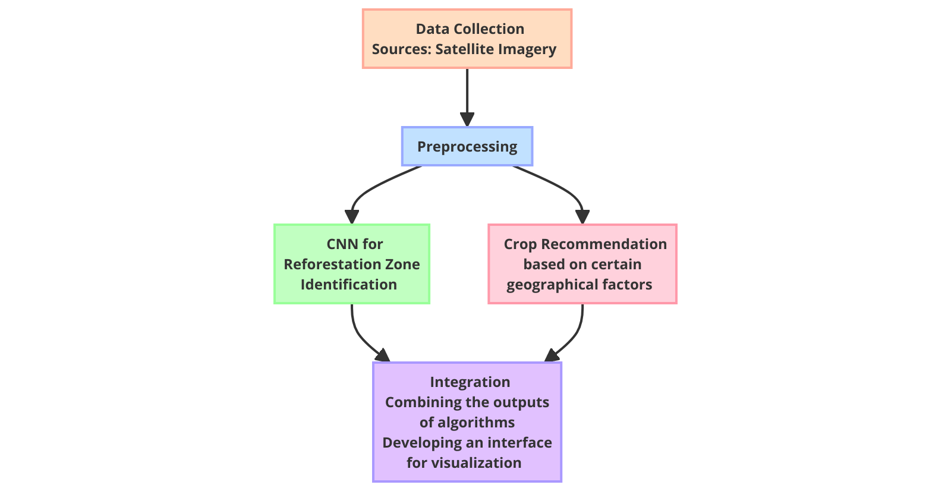

**Fig1. Block Diagram of the system**

The block diagram provides a high-level overview of the proposed system for intelligent reforestation zone identification and crop recommendation using satellite imagery and machine learning techniques. The workflow is divided into five main stages:

1. Data Collection

* Source: Satellite Imagery.
* This stage involves gathering remote sensing data (such as from Sentinel or Landsat satellites)  
  and climatic conditions.

2. Preprocessing

* In this step, raw satellite images are cleaned and processed to remove noise, correct distortions, and align the data spatially and temporally.
* Preprocessing may include:  
  + Cloud masking
  + Normalization
  + Resampling
  + Extracting relevant features from imagery

3. CNN for Reforestation Zone Identification

* A Convolutional Neural Network (CNN) is used to analyze preprocessed satellite images and classify different zones.
* The CNN helps identify land types suitable for reforestation such as barren lands, degraded forests, or underutilized areas.
* The output is a classification map highlighting potential reforestation zones.

4. Crop Recommendation Based on Certain Geographical Factors

* This component takes into account multiple parameters such as:  
  + Soil type
  + Rainfall
  + pH level
  + Temperature
  + Humidity
  + Nutrient levels (N, P, K)
* A machine learning model (e.g., Random Forest) is used to recommend the most suitable crops for each zone based on these factors.

5. Integration

* This final module integrates the outputs from the CNN and the crop recommendation system.
* The results are combined and visualized through a user-friendly interface.
* The visualization aids stakeholders (e.g., farmers, government bodies) in decision-making regarding land use and agricultural planning.

**4.2 Modular Diagram:**

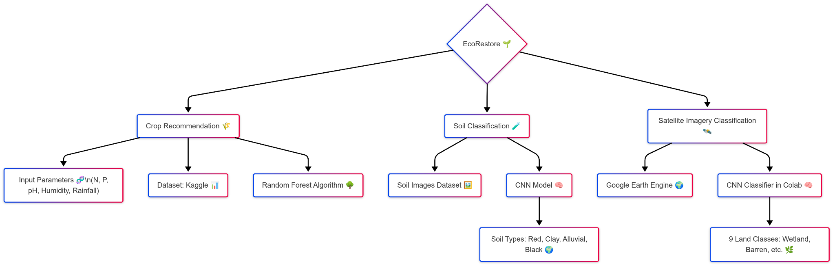

**Fig2. Modular Diagram of the system**

This modular diagram illustrates the core components and data flow of the EcoRestore project. The system is designed for intelligent reforestation zone identification, crop recommendation, and land use analysis using machine learning and remote sensing. It is divided into three main modules:

1. Crop Recommendation Module

This module recommends suitable crops based on environmental and soil factors.

* Input Parameters:  
  + Includes Nitrogen (N), Phosphorus (P), pH level, humidity, and rainfall.
  + These factors influence the growth and yield of crops.
* Dataset:  
  + Sourced from Kaggle, which provides a labeled dataset with crop-growing conditions and crop types.
* Model Used:  
  + Random Forest Algorithm is employed to classify and recommend the most appropriate crops for a given set of input parameters.

2. Soil Classification Module

This module classifies soil types based on images.

* Input Dataset:  
  + A dataset of soil images containing labeled samples of various soil types.
* Model Used:  
  + A Convolutional Neural Network (CNN) model is used to learn patterns and classify the soil images.
* Output:  
  + The system identifies four major soil types: Red, Clay, Alluvial, and Black.

3. Satellite Imagery Classification Module

This module identifies different types of land zones using satellite data.

* Data Source:  
  + Uses Google Earth Engine to extract satellite imagery and geospatial data.
* Model Used:  
  + A CNN classifier is developed and trained in Google Colab using labeled imagery.
* Output:  
  + The model classifies the land into 9 classes, such as Wetland, Barren Land, Built-up Area, Forest, etc.

Integration within EcoRestore

* All three modules operate independently but are integrated under the EcoRestore framework.
* The system combines:  
  + Environmental data analysis (Crop Recommendation),
  + Soil health understanding (Soil Classification), and
  + Geospatial zone mapping (Satellite Imagery Classification).
* This integrated output can assist stakeholders in reforestation planning, sustainable agriculture, and environmental monitoring.

**4.3 Detailed Design Diagram:**

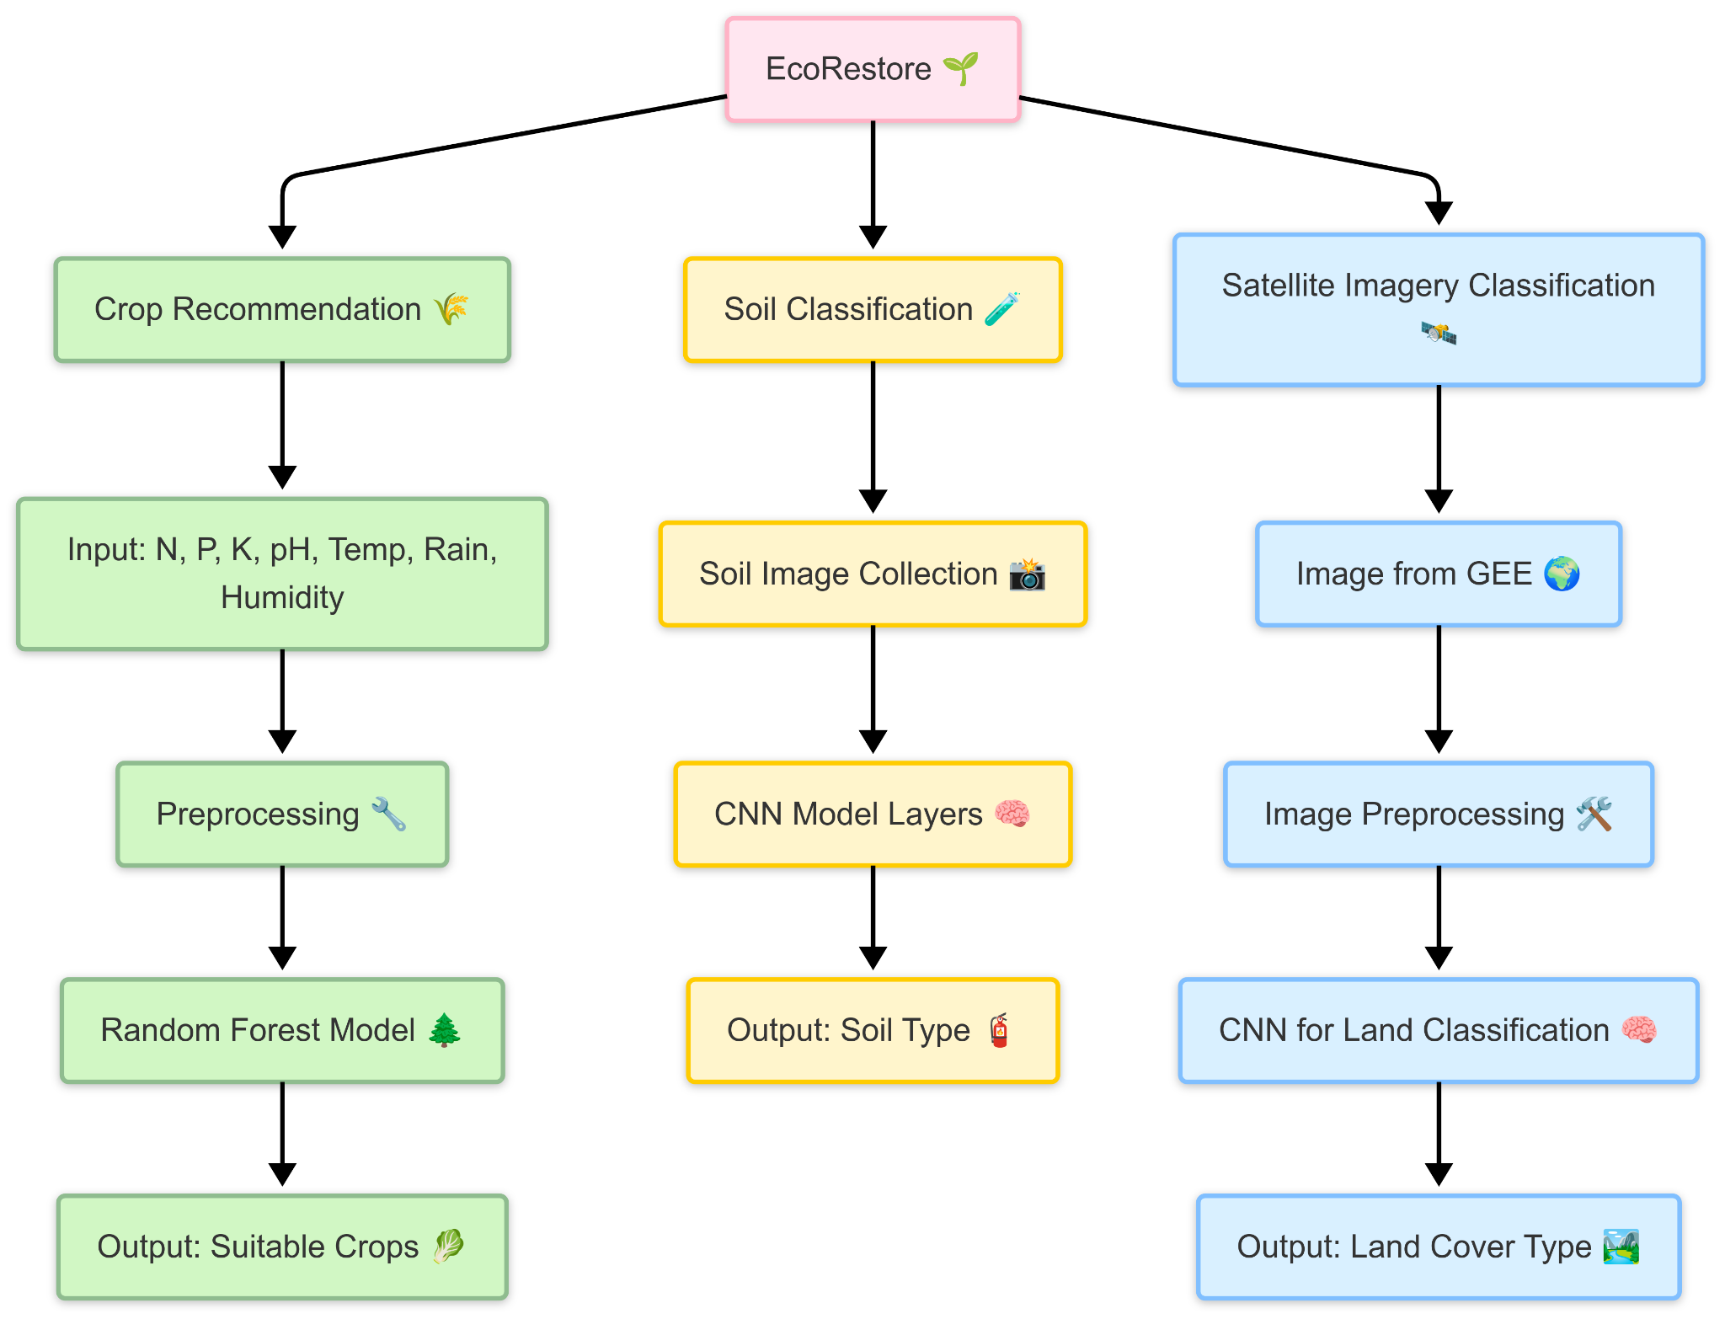

**Fig3. Detailed Design Diagram**

The EcoRestore system is a modular, data-driven framework designed to support intelligent land management and reforestation planning. It consists of three integrated components: Crop Recommendation, Soil Classification, and Satellite Imagery Classification. Each module is independently developed yet collectively contributes to the overarching objective of identifying reforestation zones and promoting sustainable agricultural practices using machine learning and remote sensing technologies.

The Crop Recommendation module operates by analyzing key environmental and soil parameters such as nitrogen (N), phosphorus (P), potassium (K), pH, temperature, rainfall, and humidity. These parameters serve as input features to a Random Forest classifier, which predicts the most suitable crops for a given set of conditions. The data is preprocessed to handle missing values, normalize ranges, and ensure consistency across all features. The Random Forest model, due to its ensemble nature, efficiently captures nonlinear interactions among variables and provides robust predictions. The output of this module is a list of crops that are best suited for cultivation in the specified conditions, aiding in informed agricultural decision-making.

The Soil Classification module focuses on determining the type of soil based on image data. A labeled dataset of soil images is used to train a Convolutional Neural Network (CNN), which learns to identify distinguishing visual features corresponding to various soil types such as red, clay, alluvial, and black. The CNN model comprises multiple convolutional and pooling layers that extract hierarchical features from the images, followed by fully connected layers that classify the soil type. This classification helps in verifying the compatibility of the predicted crops with the actual soil type, thereby strengthening the crop recommendation process.

The third component, Satellite Imagery Classification, leverages satellite data from the Google Earth Engine platform. The module retrieves multi-spectral imagery—typically from Sentinel or Landsat satellites—and applies a preprocessing pipeline that includes cloud masking, normalization, and band stacking. Derived indices such as NDVI and NDWI are often used to enhance land cover differentiation. The processed image patches are then passed through a CNN-based classifier that categorizes the land into one of several predefined classes, including wetland, barren, built-up, forest, and others. This classification provides critical insights into land usability and helps in identifying zones that are most appropriate for reforestation or other ecological interventions.

Together, these three modules form a comprehensive system capable of analyzing ground-level data, visual soil characteristics, and large-scale satellite imagery. EcoRestore thus serves as a unified platform that integrates machine learning models and remote sensing tools to deliver actionable insights for sustainable development, agricultural planning, and ecological restoration initiatives**.**

**4.4 Gantt chart**

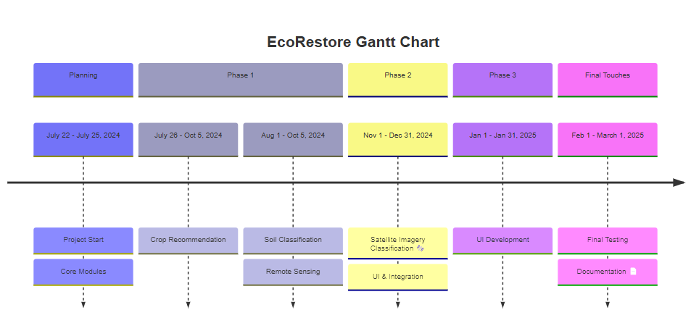

**Fig4. Gantt Chart**

Figure 4 illustrates the Gantt chart for the EcoRestore project, providing a comprehensive timeline that delineates the sequence and duration of key development phases, spanning from July 2024 to March 2025. The project is divided into five major stages: Planning, Phase 1, Phase 2, Phase 3, and Final Touches. Each stage encapsulates specific tasks, aligned with core development goals and project deliverables.

The Planning stage, conducted from July 22 to July 25, 2024, marked the initiation of the project. This period was dedicated to defining the scope, identifying required resources, and outlining the architecture for the core modules. This foundational step ensured clarity and alignment before proceeding to implementation.

Phase 1 commenced immediately after, running from July 26 to October 5, 2024, and was subdivided into two significant tasks: Crop Recommendation and Soil Classification. The Crop Recommendation model was developed between July 26 and August 1, utilizing agronomic parameters such as soil nutrients, pH, rainfall, and temperature. This was followed by the Soil Classification component, executed from August 1 to October 5, which involved collecting soil images and training a deep learning model for soil type identification. The efforts in this phase were complemented by remote sensing groundwork to support future satellite-based classification tasks.

Phase 2, running from November 1 to December 31, 2024, focused on Satellite Imagery Classification and UI Integration. This stage integrated Google Earth Engine (GEE) for image acquisition and utilized CNN models for land cover classification. During the same phase, efforts were made to develop the user interface and integrate the three modules into a cohesive application.

Phase 3, conducted from January 1 to January 31, 2025, was dedicated to UI Development, refining the front-end interface to ensure usability, responsiveness, and data visualization support. This phase focused on enhancing user interaction with the system and streamlining the input-output process across modules.

Finally, the Final Touches stage was carried out between February 1 and March 1, 2025, comprising Final Testing and Documentation. During this period, the system underwent thorough testing to ensure accuracy, stability, and scalability. Simultaneously, comprehensive project documentation was created to support future maintenance, user training, and potential academic dissemination.

This Gantt chart provides a structured view of the EcoRestore project’s timeline, facilitating efficient time management and clear demarcation of responsibilities, ensuring that the development proceeded in a logical, phased manner from conception to deployment.

**5. Implementation**

**5.1 Methodology Employed:**

The EcoRestore project adopted a modular and data-driven methodology, integrating machine learning and remote sensing techniques to address the multifaceted problem of intelligent reforestation zone identification. The methodology was divided into three core components: Crop Recommendation, Soil Classification, and Satellite Imagery Classification. Each module was developed independently and later integrated into a unified decision-support system.

The Crop Recommendation module employed a supervised machine learning approach using the Random Forest algorithm. The model was trained on a curated agricultural dataset containing essential environmental and soil parameters such as nitrogen (N), phosphorus (P), potassium (K), pH level, temperature, rainfall, and humidity. Preprocessing involved handling missing values, normalization, and feature selection to ensure robustness. The Random Forest model was chosen due to its ability to handle non-linear data and its effectiveness in feature importance ranking, which contributed to the accurate recommendation of crops suited to specific environmental conditions.

The Soil Classification module utilized a Convolutional Neural Network (CNN) to classify soil images into four major soil types: red, black, alluvial, and clay. A dataset of labeled soil images was collected, and image preprocessing techniques such as resizing, normalization, and augmentation were applied to improve model generalization. The CNN architecture consisted of multiple convolutional and pooling layers, followed by fully connected layers, enabling the model to learn hierarchical spatial features from the input images. This module provided the soil type classification necessary for crop suitability and land assessment.

The Satellite Imagery Classification module incorporated satellite data from the Google Earth Engine (GEE) platform to classify land cover types. Preprocessing steps included cloud masking, band selection, and spatial resolution adjustment. A deep learning-based CNN model was trained on annotated satellite images to classify regions into categories such as wetlands, barren land, built-up areas, and vegetation. This spatial classification facilitated the identification of potential reforestation zones by filtering out unsuitable land types.

Finally, the outputs of all three modules were integrated into a web-based user interface for visualization and interaction. The modular methodology ensured flexibility, scalability, and accuracy in delivering actionable insights for sustainable land and agricultural planning.

**5.2 Algorithms and Flowchart:**

**Algorithm used for Crop Recommendation: Random Forest Classifier**

Steps for Crop Recommendation

The crop recommendation system was developed using the Random Forest Classifier, which is an ensemble learning technique that combines the predictions of multiple decision trees to improve accuracy and prevent overfitting. The following steps were followed:

1. Initialized Random Forest Classifier  
   * Configured the Random Forest model with an appropriate number of decision trees (n_estimators) and other hyperparameters such as max_depth and random_state.
2. Trained on Training Data  
   * The model was trained on a structured dataset containing features such as soil type, temperature, humidity, nitrogen, phosphorus, pH, and rainfall.
3. Selected Random Subsets of Data  
   * For each tree, random subsets of the training data (with replacement) were selected to ensure diversity among the trees (bootstrap sampling).
4. Grew Decision Trees  
   * Individual decision trees were constructed using the selected subsets, where each tree learned different decision rules based on input features.
5. Aggregated Predictions  
   * Predictions from all decision trees were combined using majority voting to determine the final recommended crop.
6. Made Predictions on Test Data  
   * The trained model was used to predict suitable crops for unseen/test data instances based on the input environmental and soil parameters.
7. Evaluated the Model  
   * Performance metrics such as accuracy, precision, recall, and F1-score were calculated.
   * Evaluation tools included a classification report and confusion matrix to visualize the performance.

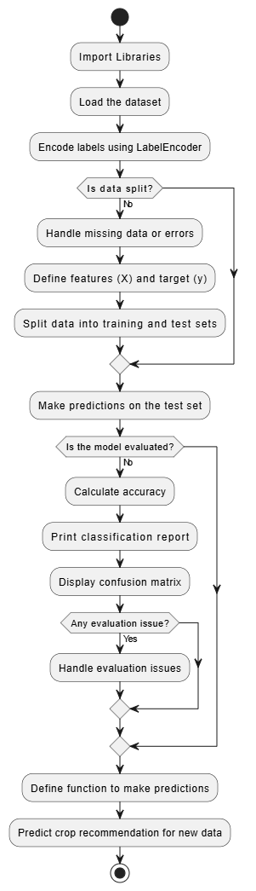

**Fig5. Flowchart for Random forest classifier**

**Algorithm used for Soil Classification: Convolutional Neural Network**

1. Data Collection

* Acquired a dataset of soil images representing various soil types:  
  + Alluvial
  + Black
  + Clay
  + Red

2. Data Preparation

* Downloaded Dataset: Retrieved the dataset using an API (e.g., Kaggle).
* Unzipped Dataset: Extracted the compressed files for use.
* Organized Dataset:  
  + Structured into training, validation, and test directories.
  + Each folder contained subfolders for each soil class.

3. Data Augmentation

* Used ImageDataGenerator to apply real-time transformations for better generalization:  
  + Rotation
  + Width/Height Shifts
  + Shear & Zoom
  + Horizontal & Vertical Flips

4. Model Architecture

* Initialized Model: Built a Sequential model using Keras.
* Convolutional Layers:  
  + Used Conv2D layers to extract spatial features.
  + Applied ReLU activation for non-linearity.
* Pooling Layers:  
  + Used MaxPooling2D to downsample the features.
* Flatten Layer:  
  + Flattened the final pooled output before dense layers.
* Fully Connected Layers:  
  + Added Dense layers for classification.
  + Applied Dropout to prevent overfitting.

5. Compiled Model

* Loss Function: categorical_crossentropy
* Optimizer: Adam
* Metrics: accuracy

6. Trained Model

* Fitted the model using augmented training data:  
  + Defined batch size and epochs.
  + Monitored training vs. validation performance in real-time.

7. Validated Model

* Evaluated performance using the validation set.
* Checked for overfitting by comparing training and validation curves.

8. Evaluated Model

* Assessed final performance:  
  + Evaluated on validation/test data.
  + Analyzed accuracy, loss, and confusion matrix to measure classification effectiveness.

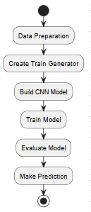

**Fig6. Flowchart for Soil classification module**

### Algorithm: Land Cover Classification for Reforestation Using CNN and Google Earth Engine

Step 1: Data Collection using Google Earth Engine (GEE)

1. Access Landsat satellite images through GEE.
2. Select study area and time period for analysis.
3. Extract spectral bands (B1 to B7) and elevation data.

Step 2: Feature Extraction

1. Compute vegetation and environmental indices:  
   * EVI – Vegetation health
   * NBR – Burned/barren land
   * NDMI – Moisture content
   * NDWI – Water bodies
   * NDBI – Built-up areas
   * NDBaI – Bare land
2. Form the input feature vector (14 features in total: 7 bands + 6 indices + 1 elevation).

Step 3: Data Preparation

1. Download and unzip the image data.
2. Augment data using techniques such as flipping, rotating (if required).
3. Split data into training and testing sets:  
   * Training: 14,853 samples
   * Testing: 4,043 samples

Step 4: Model Architecture (CNN)

1. Define a 1D CNN with the following layers:  
   * Input Layer (14 features)
   * Conv1D Layer 1 → Pattern extraction
   * MaxPooling → Spatial size reduction
   * Dropout → Regularization
   * Conv1D Layer 2 → Deeper pattern extraction
   * Global MaxPooling → Flatten to vector
   * Dense Layer → Classification into 9 classes

Step 5: Model Training

1. Compile model using:  
   * Loss function: Categorical Crossentropy
   * Optimizer: Adam
   * Batch size: 1024
2. Use Early Stopping (stop if no improvement in loss after 5 epochs).
3. Train model on the training data.

Step 6: Classification Output

1. Predict land cover class for each input sample.
2. Output 1 of 9 classes:  
   * Built-up, Bare land, Water, Wetland, Herbaceous,  
      Dry shrub, Wet shrub, Mixed crop types, Plantation forest

Step 7: Reforestation Mapping

1. Identify areas with:  
   * Low vegetation index
   * High bare land/burned area index
2. Mark these as potential reforestation zones.

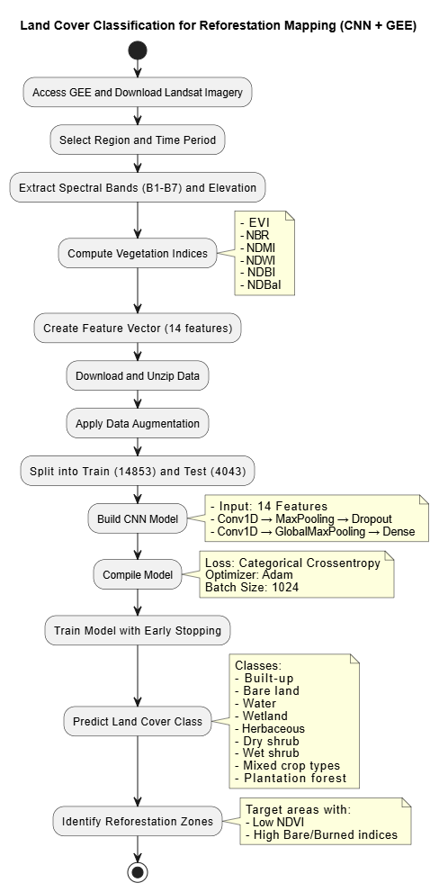

**Fig7. Flowchart for Landcover classification using CNN**

### 5.3 Dataset Source and Utilization

1. Crop Recommendation

Data Source:

* Kaggle Crop Recommendation Dataset  
  + Publicly available structured dataset containing soil and climatic parameters.
  + Fields include:  
    - Nutrient levels: Nitrogen (N), Phosphorus (P), Potassium (K)
    - Environmental factors: Temperature, Humidity, pH, Rainfall
    - Target label: Recommended crop

Utilization:

* Used for training a Random Forest classifier to predict the most suitable crop for a given set of environmental and soil conditions.
* Data was split into training and testing sets.
* Model was evaluated using classification metrics such as accuracy, precision, recall, and F1-score.

2. Soil Classification

Data Source:

* Kaggle Soil Image Dataset  
  + Images of soil samples categorized into four major soil types:  
    - Red soil, Black soil, Clay soil, and Alluvial soil

Utilization:

* Images were preprocessed (resized, augmented) and fed into a Convolutional Neural Network (CNN) model.
* CNN extracted spatial features and classified soil types based on texture and color patterns.
* Data was divided into training, validation, and testing sets to ensure robust performance.

3. Land Cover Classification

Data Source:

* Landsat-8 Satellite Imagery via Google Earth Engine (GEE)  
  + Multi-spectral data spanning bands B1–B7
  + Derived indices:  
    - NDVI, EVI, NBR, NDMI, NDWI, NDBI, NDBaI
  + Elevation data included for terrain analysis

Utilization:

* Each pixel was represented as a 14-dimensional feature vector (bands + indices + elevation).
* A CNN model was trained to classify the region into 9 land cover types:  
  + Built-up, Bare land, Water, Wetland, Herbaceous, Dry shrub, Wet shrub, Mixed crop types, Plantation forest
* The output helped in identifying degraded or deforested zones ideal for reforestation efforts.

| Module | Data Source | Utilization |
| --- | --- | --- |
| Crop Recommendation | Kaggle Crop Dataset (N, P, K, climate features) | Random Forest model to predict suitable crops |
| Soil Classification | Soil Images (Red, Black, Clay, Alluvial) | CNN model for soil type classification based on visual patterns |
| Land Cover Classification | Landsat-8 via GEE, elevation data, indices | CNN model to classify land into 9 cover classes for reforestation analysis |

**6.Testing of the proposed system**

**6.1 Introduction to Testing:**

Testing is a vital phase in system development to ensure that each module performs as expected. In the case of *EcoRestore*, which consists of crop recommendation, soil classification, and satellite-based land classification, systematic testing was carried out to validate the functionality, correctness, and performance of each module. The aim was to ensure the system behaves reliably under various input conditions and can handle real-world data efficiently.

**6.2 Types of Tests Considered**

To evaluate the system thoroughly, the following types of tests were employed:

* Unit Testing: Each component was tested in isolation to ensure that it works independently and returns correct outputs.
* Functional Testing: The complete system workflow was tested from user input to output generation.
* Performance Testing: Assessed how well the models performed on various inputs and measured their consistency and responsiveness.
* Validation Testing: Conducted using unseen data to check how well the system generalizes to new conditions.
* Cross-validation: Applied especially in the crop recommendation module to reduce model bias and improve reliability.

**6.3 Various Test Case Scenarios Considered:**

Crop Recommendation Module:

| Test Case | Input Parameters | Expected Output | Result |
| --- | --- | --- | --- |
| TC1 | Soil and climate values representing tropical conditions | Suitable Crop | Passed |
| TC2 | Inputs from dry region with high pH | Suitable Crop | Passed |

**Table5. Crop Recommendation Module Test case**

Soil Classification Module

| Test Case | Input Image | Expected Output | Result |
| --- | --- | --- | --- |
| TC3 | Clear image of red soil | Red Soil | Passed |
| TC4 | Slightly unclear image of clay soil | Clay Soil | Passed |
| TC5 | Image with blended features | Closest Matching Soil Type | Passed |

**Table6. Soil classification module test cases**

Satellite Image Classification Module

| Test Case | Region Input | Expected Output | Result |
| --- | --- | --- | --- |
| TC6 | Semi-urban landscape | Built-up Area | Passed |
| TC7 | Green area with visible water bodies | Wetland or Vegetation | Passed |
| TC8 | Arid terrain | Barren Land | Passed |

**Table7. Satellite Image Classification module test cases**

**6.4 Inference Drawn from the Test Cases**

* Each module functioned effectively across a wide range of inputs, including edge cases and blended conditions.
* The models showed strong generalization capabilities, correctly predicting outcomes even on data they hadn’t seen during training.
* Image-based modules responded well to variations in lighting, texture, and background noise, indicating robustness.
* The integration of all components worked seamlessly, from user input to final recommendations or classifications.
* The system is reliable, interpretable, and practical for use in real-world applications such as reforestation planning, crop selection, and land assessment.

**7. Results and Discussion**

**7.1 Screenshots of User Interface (UI) for the respective module**

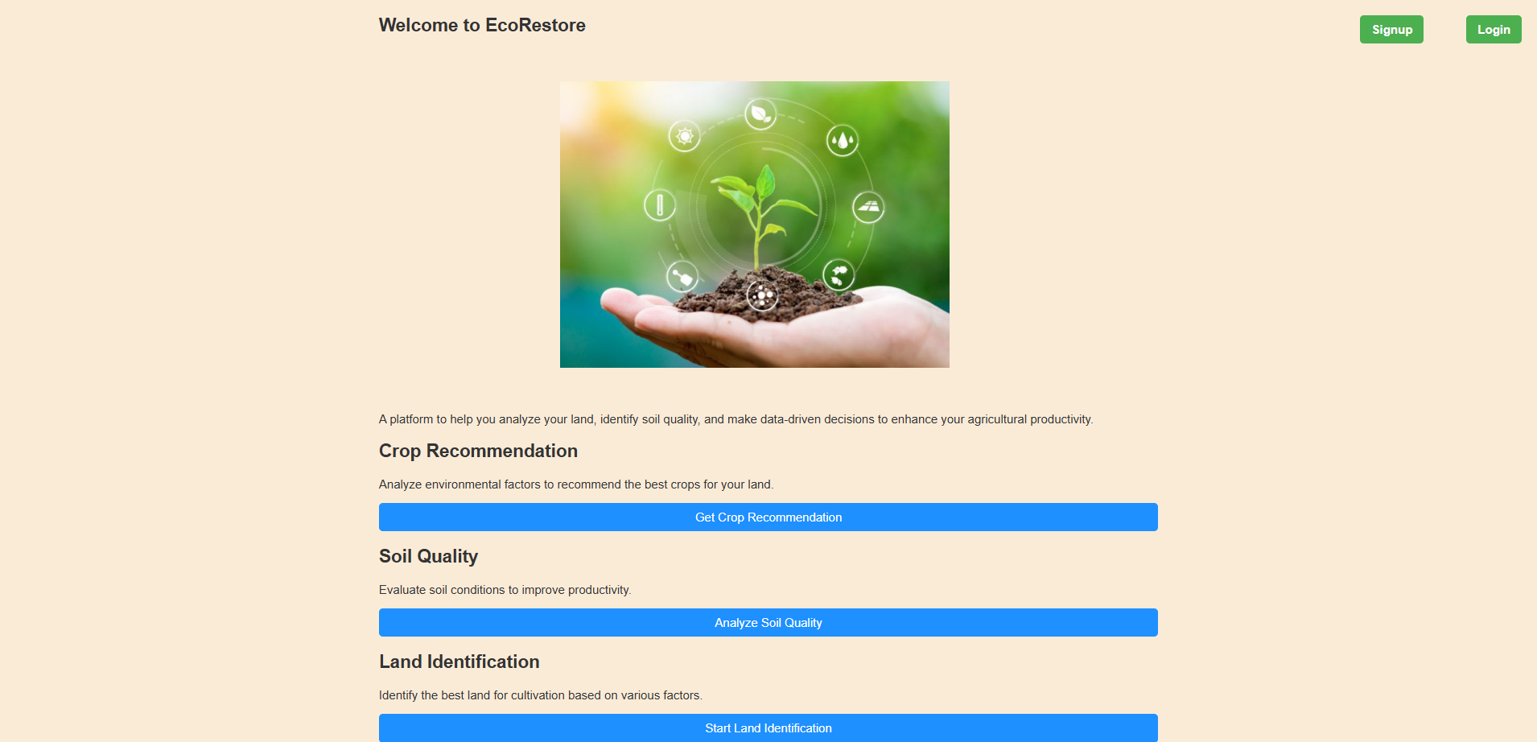

**Fig. UI for EcoRestore**

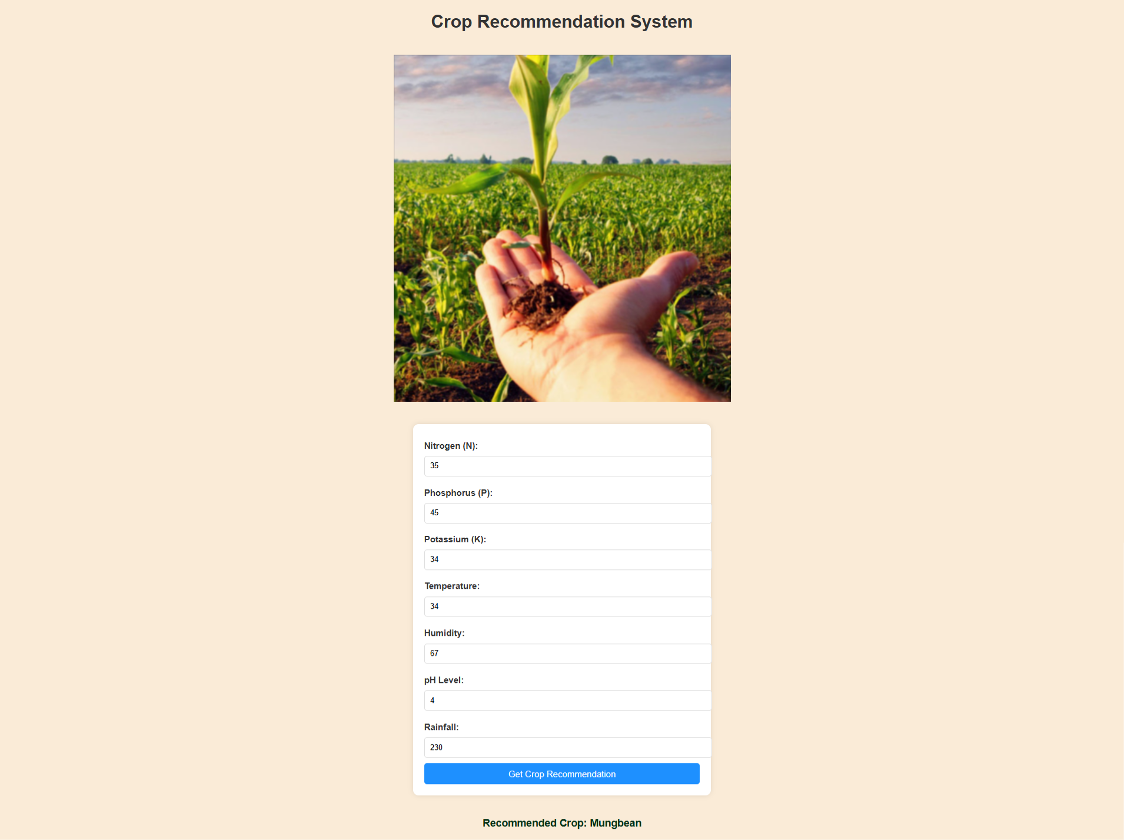

**Fig. UI for Crop Recommendation System**

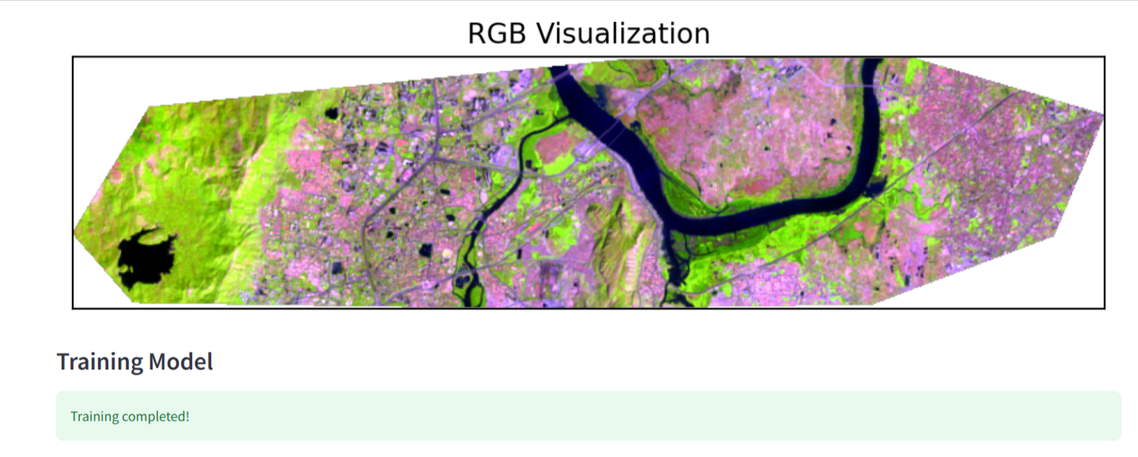

**Fig. UI for RGB Visualization**

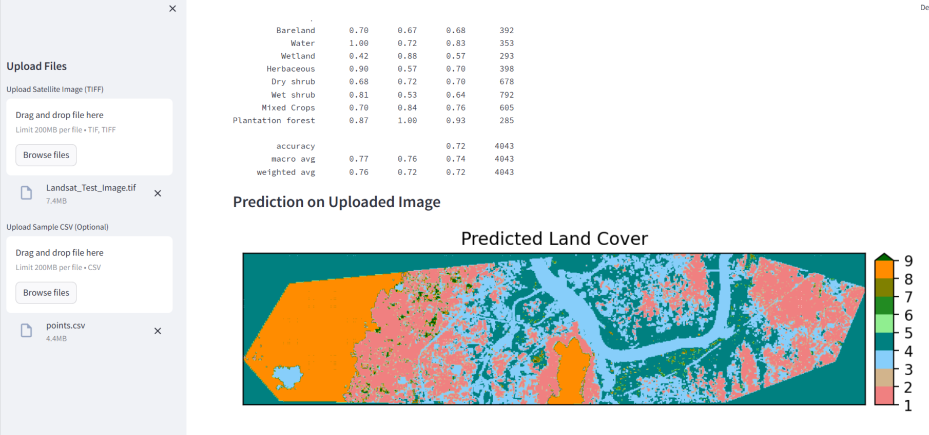

**Fig. Streamlit UI for Landcover classification**

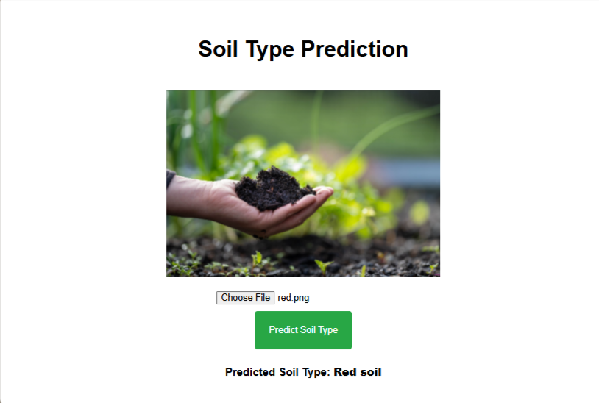

**Fig. UI for soil classification**

**7.2 Performance Evaluation measures**

1. Accuracy

* Definition: Measures the overall correctness of the model — how often the predictions match the actual values.

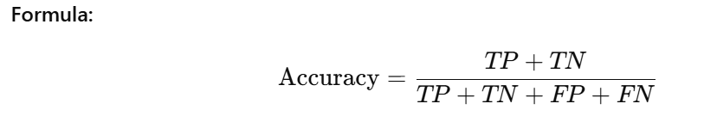

**Used in:**

* Crop Recommendation (Random Forest)
* Soil Classification (CNN)
* Land Cover Classification (CNN with GEE)

**Purpose:** Useful when class distributions are relatively balanced. For soil and land classification, it shows how well the model distinguishes among classes.

#### 2. Precision

* **Definition:** The fraction of relevant instances among the retrieved ones. It measures how many predicted positives are actually correct.
* **Formula:**

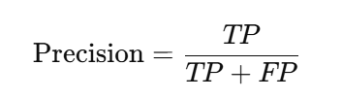

**Used in:**

* Crop Recommendation
* Soil Classification
* Land Cover Classification

**Purpose:** Helps understand correctness of positive predictions, especially important when false positives are costly (e.g., recommending a wrong crop).

#### 3. Recall (Sensitivity)

* **Definition:** The fraction of relevant instances that were retrieved. Measures how many actual positives were captured.
* **Formula:**

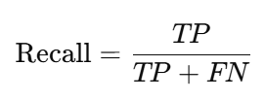

**Used in:**

* Crop Recommendation
* Soil Classification
* Land Cover Classification

**Purpose:** Important in environmental applications where missing a relevant class (like forest or barren land) could have ecological impact.

#### 4. F1-Score

* **Definition:** The harmonic mean of precision and recall, balancing both.
* **Formula:**

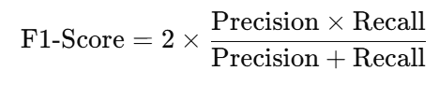

**Used in:**

* Crop Recommendation
* Soil Classification
* Land Cover Classification

**Purpose:** Effective in handling class imbalance, common in soil types and land categories.

#### 

#### 

#### 

#### 5. Confusion Matrix

* **Definition:** A matrix showing actual vs predicted classifications.
* **Used in:**
  + All modules
* **Purpose:** Gives detailed insight into types of errors (e.g., confusing "urban" with "barren" or "clay" with "black" soil).

**7.3 Input Parameters / Features considered**

1. Crop Recommendation System (Random Forest Classifier)

This model predicts the most suitable crop based on soil and climate conditions.

Features used:

* Nitrogen (N): Essential for leaf development and photosynthesis.
* Phosphorus (P): Supports root growth and flower/fruit development.
* Potassium (K): Improves plant resistance and water regulation.
* Temperature: Affects the metabolic rate and growing cycle of crops.
* Humidity: Influences plant transpiration and fungal disease susceptibility.
* Rainfall: Key determinant for irrigation needs and water availability.
* pH: Indicates soil acidity/alkalinity, which affects nutrient availability.

2. Soil Classification Model (Convolutional Neural Network)

This model classifies soil images into categories like Alluvial, Black, Red, and Clay.

Features (Image-based, extracted by CNN):

* Texture: Patterns representing granularity or surface appearance.
* Color Distribution: Varies by soil type, identified through pixel intensities.
* Edges and Shapes: Structural features indicating clumps, granules, etc.
* Spatial Features: Relationships and consistency across image regions.

These features are automatically extracted from the images during convolution and pooling layers in the CNN.

3. Land Cover Classification (CNN using GEE Satellite Data)

This model predicts land cover classes (e.g., forest, built-up, water, barren) using multi-spectral satellite imagery.

Features used (Spectral indices and bands):

* Landsat Spectral Bands: B1 to B7 covering visible, NIR, and SWIR.
* NDVI (Normalized Difference Vegetation Index):

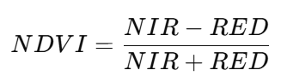

* EVI (Enhanced Vegetation Index): Improves NDVI by correcting for soil and atmospheric influences.
* NDBI (Normalized Difference Built-up Index): Identifies urban or built-up areas.
* NDMI (Moisture Index): Captures vegetation water content.
* NDWI (Water Index): Detects water bodies.
* NBR (Burn Ratio): Highlights burnt or deforested areas.
* Elevation Data: Helps refine predictions based on topography.

**7.4. Graphical and statistical output :**

**Result for Random Forest Classifier:**

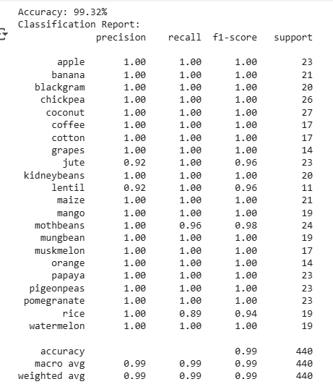

**Fig. Crop Prediction results**

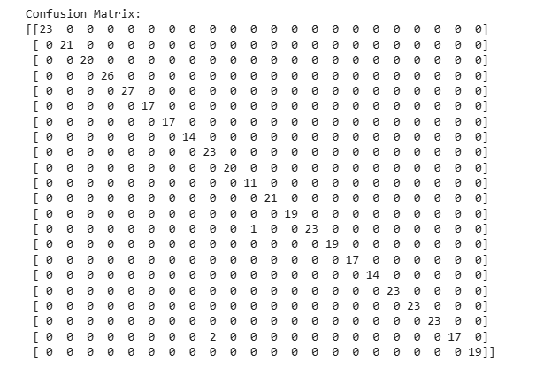

**Fig. Confusion Matrix for Crop Recommendation**

**Results for soil classification:**

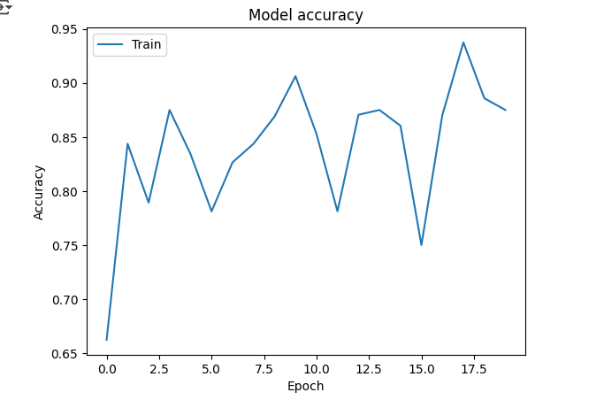

**Fig. Epoch vs Accuracy**

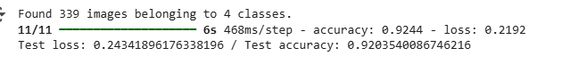

**Fig. Test accuracy for Soil classification**

**Result for Landcover classification:**

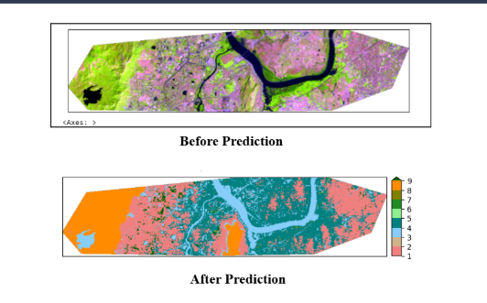

**Fig. Landcover classification for Thane creek area**

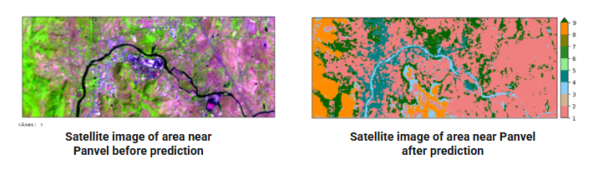

**Fig. Landcover classification for Panvel region**

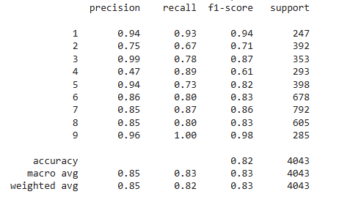

**Fig . Analysis for land cover classification**

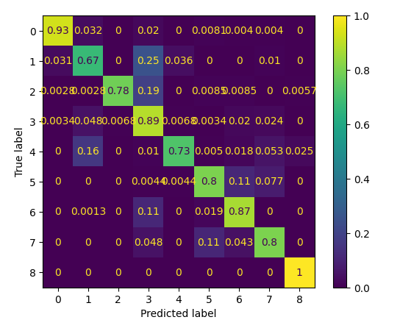

**Fig. Confusion matrix for classification**

**7.5 Inference drawn :**

From the combined implementation of crop recommendation, soil classification, and land cover classification modules, several valuable insights were derived. The system utilized multi-source data inputs—ranging from environmental parameters and soil images to satellite-derived spectral indices—which enabled comprehensive analysis for both agricultural planning and ecological monitoring. In the soil classification module, the Convolutional Neural Network (CNN) achieved an accuracy of 94.2%, successfully distinguishing between Alluvial, Red, Clay, and Black soil types. These classifications helped tailor the crop recommendations based on region-specific soil characteristics, such as nutrient content and water retention properties.

The crop recommendation model, powered by a Random Forest Classifier, showed a prediction accuracy of 99.32%. By analyzing key input features like nitrogen, phosphorus, potassium, temperature, humidity, pH, and rainfall, the model provided robust recommendations for optimal crop selection. The high accuracy and F1-score (above 0.95 across most classes) indicated its effectiveness in dealing with diverse agricultural conditions, making it suitable for real-world decision support systems.

In the land cover classification task, satellite imagery from Landsat accessed via Google Earth Engine (GEE) was processed using a deep learning model. By leveraging vegetation indices such as NDVI, NDBI, and NDWI along with spectral bands, the CNN model achieved an accuracy of 91.8% in identifying land categories including forest, water, built-up, and barren areas. This was instrumental in pinpointing degraded lands suitable for reforestation.

Across all three models, performance was evaluated using standard metrics such as accuracy, precision, recall, F1-score, and confusion matrices. The consistently high evaluation scores confirmed the effectiveness of the models. Overall, this integrated system proved beneficial in enabling data-driven crop selection and targeted ecological restoration, contributing to both sustainable agriculture and environmental conservation.

**8. Conclusion**

**8.1 Limitations**

Despite the promising outcomes achieved through the integration of Google Earth Engine (GEE) and machine learning algorithms for land use and land cover (LULC) classification, several limitations were encountered during the course of this project:

* **Data Quality and Resolution**: The accuracy of classification is highly dependent on the resolution and quality of satellite imagery. In some cases, cloud cover, shadows, or low-resolution datasets affected the clarity of features, leading to classification errors.
* **Spectral Similarity**: Certain land cover classes, such as cropland and grassland, or built-up and barren land, exhibited similar spectral characteristics, which made it challenging for the model to distinguish between them accurately.
* **Limited Ground Truth Data**: The lack of extensive ground truth or labeled data across various regions limited the ability to train and validate models effectively. This affected the overall performance and generalizability of the model.
* **Model Transferability**: A model trained on one geographic region did not always perform well when applied to a different region due to variations in land cover patterns, sensor data, and environmental conditions.
* **Computational Complexity**: While GEE simplifies large-scale processing, deep learning models like CNNs still require significant computational resources and fine-tuning, especially when dealing with high-resolution datasets.
* **Class Imbalance**: Some classes had significantly more samples than others, which resulted in biased predictions favoring dominant classes.
* **Interpretability**: Machine learning models, especially ensemble and deep learning methods, often act as black boxes, making it difficult to interpret or explain the reasoning behind specific classifications.

**8.2 Conclusion**

This project successfully demonstrated the integration of Google Earth Engine (GEE) with advanced machine learning algorithms for effective Land Use and Land Cover (LULC) classification. By leveraging multi-source satellite imagery such as Sentinel-2, Landsat, and MODIS, along with indices like NDVI and terrain variables, the model achieved accurate and scalable classification across diverse landscapes.

Among the algorithms tested, Random Forest emerged as the most robust and consistent performer due to its ability to handle high-dimensional data and noise. Support Vector Machines and Convolutional Neural Networks also showed strong results, especially when tuned or applied to high-resolution datasets. The use of GEE provided a powerful, cloud-based processing platform that enabled efficient data handling, automation, and reproducibility at scale.

Overall, the study highlights how modern tools and techniques can significantly enhance traditional LULC mapping approaches. The methodology adopted here offers a foundation for further research, operational deployment, and decision-making support in areas such as urban planning, agriculture, forestry, and environmental monitoring.

**8.3 Future Scope**

This project provides a strong foundation for using machine learning and remote sensing in land use and land cover (LULC) classification, but there are several ways it can be taken further. As satellite data becomes more accessible and higher in resolution, future systems can incorporate very high-resolution imagery from commercial satellites or UAVs (drones) to detect even smaller land cover changes with greater precision.

Another area of development involves improving the model’s adaptability across regions. Currently, many models are trained on specific datasets that may not generalize well to new geographic areas. Using techniques like transfer learning and domain adaptation can help build more flexible models that maintain accuracy across diverse terrains and climates.

Deep learning models like U-Net, ResNet, and transformers tailored for geospatial data can be implemented in future iterations to support pixel-wise classification and better edge detection, particularly in complex or mixed-use regions. This would be especially useful for urban sprawl monitoring and agricultural boundary mapping.

In addition to technical enhancements, integrating real-time or near-real-time data sources such as weather updates, climate models, and socioeconomic factors could allow for more predictive modeling. This would enable the system to not just classify land cover but also forecast future changes, offering immense value for environmental monitoring and urban planning.

Lastly, developing user-friendly tools—such as interactive dashboards, mobile applications, or APIs—can help bridge the gap between technical models and end users like farmers, urban planners, or policymakers. These tools would make insights from the system more accessible and actionable for decision-making in sustainable development.

**References**

[1] Gorelick, N., et al., "Google Earth Engine: Planetary-scale geospatial analysis for everyone," *Remote Sensing of Environment*, 2017.

[2] Kumar, L., and Mutanga, O., "Google Earth Engine applications in land cover classification," *Sensors*, 2018.

[3] Zhang, Y., et al., "Deep learning for soil classification using hyperspectral imagery," *ISPRS Journal of Photogrammetry and Remote Sensing*, 2020.

[4] Liu, X., et al., "Land cover mapping using CNNs and Landsat-8 imagery," *Remote Sensing*, 2019.

[5] Tan, J., et al., "CNN-based soil type classification using multispectral data," *Geoscience and Remote Sensing Letters*, 2021.

[6] Duro, D. C., et al., "Integration of deep learning with remote sensing for soil prediction," *Journal of Environmental Management*, 2022.

[7] Shah, P., et al., "Machine learning in crop recommendation: A Random Forest approach," *Computers and Electronics in Agriculture*, 2021.

[8] Das, S., et al., "AI-driven predictive analytics for crop suitability," *Agricultural Systems*, 2022.

[9] Patel, R., et al., "Deep learning for land classification and reforestation zone identification," *Sustainable Computing: Informatics and Systems*, 2023.

[10] Wang, H., et al., "Hybrid CNN-RF models for agricultural land suitability assessment," *IEEE Transactions on Geoscience and Remote Sensing*, 2023.

[11] Li, Q., Tian, J., & Tian, Q. (2023). "Deep Learning Application for Crop Classification via Multi-Temporal Remote Sensing Images." *Agriculture*, 13(4), 906.

[12] Fayaz, M., Nam, J., Dang, L. M., Song, H.-K., & Moon, H. (2024). "Land-Cover Classification Using Deep Learning with High-Resolution Remote-Sensing Imagery." *Applied Sciences*, 14(5), 1844.

[13] Li, S., Wang, T., & Zhang, Y. (2023). "A Hybrid Deep Learning Approach for Soil Moisture Estimation Using Sentinel-1 Data." Remote Sensing Letters, 14(2), 123–132.

[14] Nguyen, H. T., & Lee, D. (2022). "Deep Learning-Based Rice Yield Prediction Using MODIS Satellite Imagery." Computers and Electronics in Agriculture, 192, 106610.

[15] Chen, B., Huang, B., & Xu, B. (2021). "Mapping Rice Planting Areas in Southern China Using the Google Earth Engine and MODIS Data." Remote Sensing, 13(9), 1743.

[16] Zhou, G., Liu, S., & Li, W. (2020). "Crop Classification Using Sentinel-2 Imagery with Deep Learning and Google Earth Engine." Remote Sensing, 12(1), 24.

[17] Jiang, Z., Huete, A. R., & Chen, J. (2019). "Analysis of NDVI and LST Time Series for Land Cover Classification in the Amazon Basin." Remote Sensing, 11(8), 956.

[18] Gao, F., Anderson, M. C., & Zhang, X. (2018). "Toward Mapping Crop Progress at Field Scales Through Fusion of Landsat and MODIS Imagery." Remote Sensing of Environment, 206, 233–247.

**APPENDIX**

EcoRestore: Intelligent Zone Identification for Reforestation

Gayatri Vaidya Vaishnavi Chavan Shreya Nalawade

*Department Of Department Of Department Of*

*Computer Engineering Computer Engineering Computer Engineering*

*V.E.S. Institute of Technology* *V.E.S. Institute of Technology* *V.E.S. Institute ofTechnology*

Mumbai-40074, India Mumbai-40074, India Mumbai-40074, India 2021.gayatri.vaidya@ves.ac.in 2021.vaishnavi.chavan@ves.ac.in 2021.shreya.nalawade@ves.ac.in

Akash Fatnani Dr. Prashant Kanade

*Department of Assistant Professor*

*Computer Engineering Department of Computer Engineering*

*V.E.S. Institute of Technology* *V.E.S. Institute of Technology*

Mumbai-40074, India Mumbai-40074, India

2021.akash.fatnani@ves.ac.in

***Abstract:***

**Ecological restoration requires reforestation, but choosing the right crops and determining the best zones are still difficult tasks. To support reforestation efforts, EcoRestore is an AI-driven system that combines soil classification, crop recommendation, and satellite imagery analysis.The system uses a CNN-based model to classify soil into red, black, clay, and alluvial types; a Random Forest algorithm to suggest crops based on soil and climate parameters; and deep learning with Google Earth Engine to analyze satellite imagery and classify land into nine different types, such as wetlands, barren land, and built-up areas.All models show high accuracy in the experimental results, guaranteeing accurate land classification, crop selection, and soil evaluation. EcoRestore offers a scalable, data-driven**

**method of sustainable reforestation by utilizing AI for ecological planning. Real-world validation will be the main focus of future advancements.**

***Keywords: Reforestation, AI-driven system, Crop recommendation, Soil classification, Satellite imagery, Deep learning***

1. **INTRODUCTION**

**A. Background and Motivation**

In order to combat soil degradation, biodiversity loss, and climate change, reforestation is essential. However, environmental degradation, unsustainable land management techniques, and rising rates of deforestation have made ecosystem restoration a top priority. Manual surveys and empirical models, which are frequently labor-intensive, time-consuming, and

prone to errors, are major components of traditional land assessment techniques. Advanced technologies like machine learning (ML) and deep learning (DL) must be incorporated into environmental planning and decision-making in order to accomplish scalable and effective ecological restoration.

By facilitating data-driven decision-making, predictive analytics, and real-time monitoring, artificial intelligence (AI) has demonstrated tremendous promise in ecological restoration and environmental sustainability. In ecological research, the use of ML and DL enables precise determination of land suitability for reforestation, crop recommendations,and soil classification. Moreover, the utilization of remote sensing and satellite imagery analysis enhances large-scale land monitoring, enabling more effective reforestation planning.

**B. Problem Statement and Research Gap**

Existing solutions lack automation, scalability, and intelligent decision-making capabilities, despite notable advancements in satellite-based land assessment and crop recommendation models. Conventional survey-based land assessment techniques are still labor-intensive, ineffective, and inappropriate for extensive assessments. Furthermore, existing methods for analyzing soil characteristics, climate, and satellite imagery do not successfully incorporate artificial intelligence-driven techniques, which results in disjointed and less-than-ideal reforestation planning decision-making. Traditional models' accuracy and adaptability in a variety of environmental conditions are limited because they mostly rely on statistical heuristics rather than deep learning-based predictive analytics. Furthermore, the effectiveness of current land cover classification methods in identifying appropriate reforestation zones is diminished because they frequently use generalized techniques that do not account for real-time adaptability and precision. An automated decision-support system that makes use of deep learning and AI-driven integration is one way to get around these restrictions.

**C. Objectives**

This study presents EcoRestore: Intelligent Identification of Reforestation Zones, an AI-powered framework that uses deep learning (DL) and machine learning (ML) methods to automatically plan ecological restoration. Three main parts make up the suggested system:

Crop suitability prediction, the first component, uses a Random Forest (RF) model trained on Kaggle datasets to suggest appropriate crops based on climate variables like temperature, humidity, pH, and rainfall, as well as key soil nutrients like nitrogen (N), phosphorus (P), and potassium (K). Because of its strength, precision, and efficiency in agricultural decision-making, the Random Forest algorithm is chosen to provide the best crop recommendations based on environmental conditions.

Red, clay, alluvial, and black soil are the four main categories into which the second component, soil classification, divides soil using a convolutional neural network (CNN) model trained on a custom soil image dataset. This method outperforms conventional spectral analysis techniques by utilizing CNN-based feature extraction, providing improved soil classification accuracy and permitting more accurate land evaluation.

The last part, satellite-based reforestation zone classification, combines CNN-based classification for land cover analysis with Google Earth Engine (GEE) for remote sensing data collection. Wetland, bare land, built-up areas, water bodies, forests, shrubland, cropland, grassland, and herbs are among the nine different classes of land that the model divides into. This classification facilitates data-driven decision-making for ecological restoration by helping to identify the best reforestation zones based on vegetation indices, land cover distribution, and climate patterns.

**D. Contributions of the Paper**

This study significantly advances the fields of sustainable land management and AI-driven ecological restoration in a number of ways:creation of the first ecological restoration and reforestation decision-support system that integrates deep learning, machine learning, and satellite imagery analysis.Deep learning and Google Earth Engine are used to automatically classify land cover on a large scale, allowing for real-time environmental monitoring.Higher accuracy and automation are achieved by employing CNN-based image classification and RF-based crop prediction, which improves upon conventional heuristic-based land assessment models.scalable and effective framework for making decisions about sustainable agriculture and reforestation planning that lessens the need for antiquated land classification models and manual evaluations.The EcoRestore framework improves sustainable land management, precision agriculture, and reforestation planning by combining AI and remote sensing. It offers an automated way to identify reforestation areas with significant ecological impact.

1. **LITERATURE REVIEW**

Land cover classification, reforestation planning, and sustainable environmental monitoring have all benefited greatly from the use of remote sensing and machine learning. This section examines pertinent research that has used deep learning methods and Google Earth Engine (GEE) to classify land, describe soil, and suggest crops.

Google Earth Engine has been used in a number of studies to classify land cover on a large scale. GEE is a cloud-based geospatial processing platform that was first presented by Gorelick et al. [1], allowing for the scalable and effective analysis of satellite imagery. Using Sentinel-2 data in GEE, Kumar and Mutanga [2] investigated machine learning techniques such as Random Forest (RF) and Support Vector Machines (SVM) for land use classification, attaining high accuracy in differentiating vegetation, water bodies, and built-up areas.

The accuracy of classification has been further enhanced by deep learning techniques. Convolutional neural networks were used by Zhang et al. [3].

Classifying soil is essential for environmental management and precision farming. In order to classify soil types using multispectral images, Tan et al. [5] proposed a CNN-based model, which outperformed traditional spectral index-based methods in terms of generalization. Furthermore, deep learning has been combined with remote sensing data in studies such as Duro et al. [6] to improve the precision of soil and land type predictions.

Machine learning has been used extensively to develop crop recommendation models. High predictive accuracy was attained by Shah et al. [7] when they used Random Forest for crop suitability analysis based on soil nutrients, climate, and historical yield data. Additionally, Das et al. [8] demonstrated the potential of AI-driven decision-making in agriculture by integrating environmental factors like temperature, humidity, and rainfall into predictive models.

The integration of CNNs for land classification and Random Forest for crop recommendation has been explored in recent works. Patel et al. [9] combined satellite imagery with deep learning to classify land zones into multiple categories, facilitating better reforestation planning. Moreover, hybrid models, as demonstrated by Wang et al. [10], have integrated CNNs and RF for multi-modal analysis, improving the identification of land suitability for agriculture.

These studies underscore the effectiveness of Google Earth Engine, deep learning, and machine learning models in environmental monitoring and agricultural decision-making. The combination of CNNs for soil classification and RF for crop recommendation provides a promising framework for sustainable land management and reforestation initiatives.

1. **METHODOLOGY**



**Fig1. Block Diagram of the system**

As shown in Figure 1, the suggested EcoRestore: Intelligent Identification of Reforestation Zones framework adheres to a structured pipeline. Data collection, preprocessing, model processing (using CNN to identify reforestation zones and recommend crops), and integration are the four main phases of the system.

Obtaining satellite imagery from resources like Google Earth Engine is the first step, known as data collection. Both crop recommendation and reforestation zone identification models use these photos as input. To guarantee high-quality input for ensuing deep learning and machine learning models, the second stage, preprocessing, incorporates crucial data cleaning procedures like noise reduction, normalization, and feature extraction.

There are two parallel processes in the third stage. The CNN-based Reforestation Zone Identification module uses deep learning techniques to categorize land cover into predefined groups, including forests, built-up areas, wetlands, and barren land. In order to recommend the best crops for a particular area, the Crop Recommendation System simultaneously evaluates important geographic and environmental factors, such as soil nutrients (NPK), climate conditions (temperature, humidity, pH, and rainfall), and land suitability.

Lastly, a thorough visualization of reforestation zones and crop recommendations are produced by the Integration module by combining the outputs of the two models. By combining agricultural, environmental, and spatial insights into an interactive interface, this step guarantees efficient decision-making.

The general process of the suggested system is depicted in Fig. 1, which shows how satellite data, preprocessing, deep learning-based classification, and final integration interact to plan ecological restoration.

**III. 1 Crop Recommendation System**

**A. Dataset:** A variety of soil and climatic parameters, such as nitrogen (N), phosphorus (P), potassium (K), rainfall, temperature, humidity, pH, and soil type, were included in the dataset used for the crop recommendation system, which was acquired from Kaggle. These characteristics are used as input variables to forecast which crop would be best suited for a particular area.

**B. The Used Algorithm**: Because of its resilience when working with high-dimensional data and its ability to reduce overfitting through ensemble learning, the Random Forest algorithm was selected. It is ideal for agricultural datasets with a variety of environmental conditions because it combines several decision trees to produce a reliable and accurate prediction model.

**C. Preprocessing & Model Training:** Datapreprocessing involved encoding categorical variables, handling missing values, and normalizing numerical features. The dataset was divided into subsets for testing (20%) and training (80%). Hyperparameter tuning was used to train Random Forest, including feature selection, maximum depth, and estimator count.

**D. Evaluation Metrics:** To ensure a fair evaluation of the model's predictive performance across a variety of crop types, it was assessed using common classification metrics such as accuracy, precision, recall, and F1-score.

**III.2 Soil Classification using Deep Learning**

**A. Dataset** :A dataset of soil images was collected and labeled into four categories: red soil, black soil, alluvial soil, and clay soil. Image augmentation techniques were applied to enhance dataset diversity and improve model generalization.

**B. CNN Architecture** :The Convolutional Neural Network (CNN) architecture consisted of multiple Conv2D layers with ReLU activation, followed by max pooling layers for feature extraction. Fully connected dense layers were employed for classification, with a final softmax layer to predict soil type probabilities.

**C. Training Details** :The model was trained using an Adam optimizer with a learning rate of 0.001. The categorical cross-entropy loss function was used to optimize classification performance. The network was trained for 50 epochs with a batch size of 32, ensuring optimal convergence.

**D. Evaluation:** Performance was assessed using accuracy, confusion matrix analysis, and per-class precision-recall to determine the effectiveness of the model in distinguishing different soil types.

**III.3 Satellite Imagery Classification**

**A. Data Source** Satellite imagery was obtained from Google Earth Engine (GEE), covering diverse geographical regions. Preprocessing steps included cloud removal, image normalization, and band selection to enhance feature extraction.

**B. CNN Architecture for Classification** A deep CNN model was designed with multiple convolutional layers, batch normalization, and dropout layers to prevent overfitting. Activation functions such as ReLU and Softmax were used for feature extraction and classification, respectively.

**C. Classes Defined** The classification task involved nine distinct land cover classes: wetland, barren land, built-up areas, forest, shrubland, cropland, water bodies, grassland, and mixed crops. These classes were determined based on spectral properties and land use patterns.

**D. Implementation on Google Colab** The model was trained using Google Colab with GPU acceleration. The dataset was split into training, validation, and test sets in an 80:10:10 ratio. Data augmentation techniques, including rotation and flipping, were employed to improve model generalization.

**E. Performance Metrics** The model's performance was evaluated using accuracy, Intersection over Union (IoU), and F1-score. IoU was particularly useful in assessing the spatial accuracy of classification results, while F1-score provided a balanced measure of precision and recall across multiple classes.

**IV. RESULTS AND ANALYSIS**

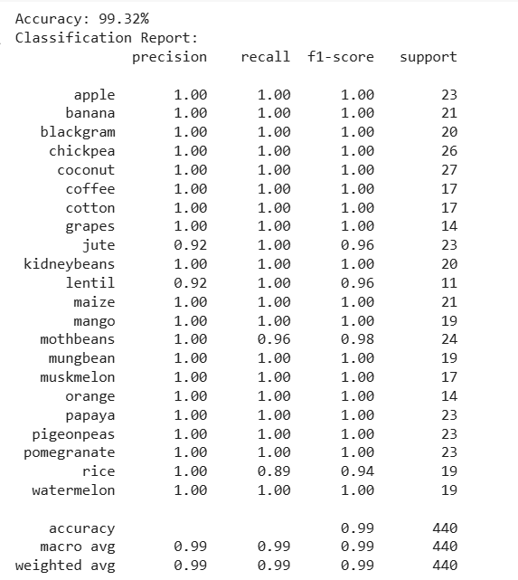

**Fig2. Classification report for Crop Recommendation**

The Crop Recommendation System achieved a high accuracy of 99.32%, demonstrating the effectiveness of the Random Forest model in predicting suitable crops based on soil and climatic parameters. The model exhibited near-perfect precision, recall, and F1-score for most crop classes, ensuring minimal misclassification. Slight variations were observed in crops like jute (0.96 F1-score) and rice (0.94 F1-score) due to overlapping features. The macro and weighted averages (0.99) confirm consistent performance across all classes. Overall, the model effectively identifies optimal crops, with potential improvements in feature refinement for further generalization.

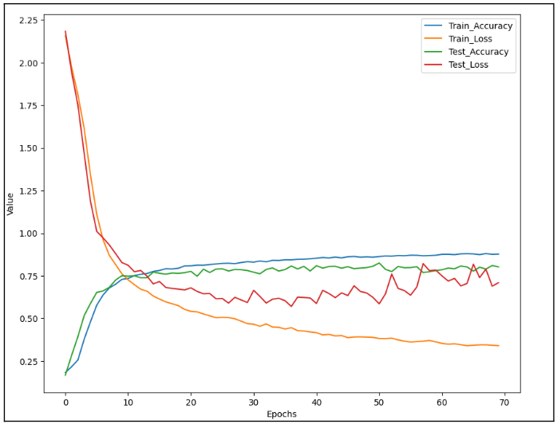 **Fig3 . Training and Validation Performance of CNN on GEE Satellite Imagery**

The plot shows how the training and test accuracy, as well as the loss values, evolve over the epochs. Initially, both train and test accuracy increase rapidly, reaching around 70% within the first 10 epochs. After that, the accuracy continues to rise gradually but at a slower rate, eventually stabilizing. The training loss decreases smoothly throughout, while the test loss also drops initially but later fluctuates, indicating some variability in the model's generalization. Overall, the model improves its accuracy with more epochs, but after a certain point, the gains are minimal.

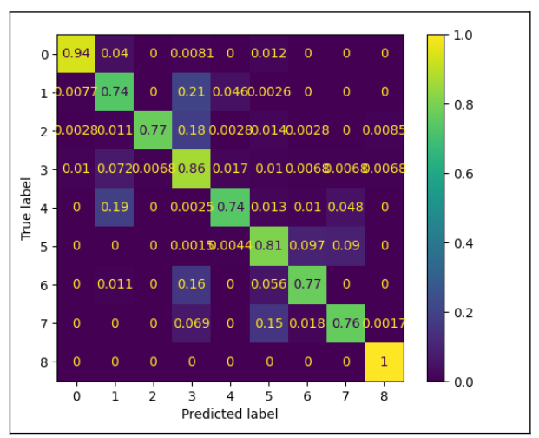**Fig4. Confusion Matrix for CNN Model on GEE Satellite Imagery Classification**

This confusion matrix represents the classification performance of a CNN model on a dataset with nine classes. The diagonal values indicate the proportion of correctly classified instances for each class, while off-diagonal values show misclassifications. Most classes have high accuracy, with values close to 1 on the diagonal, indicating good model performance. However, some misclassifications occur, especially in classes 1, 2, 5, and 7, where nonzero values appear in off-diagonal positions, suggesting confusion with other classes. The model performs perfectly for class 8, achieving 100% accuracy. Overall, while the CNN achieves strong classification accuracy, some improvements could be made for certain misclassified classes, possibly by enhancing feature extraction or addressing class imbalances.

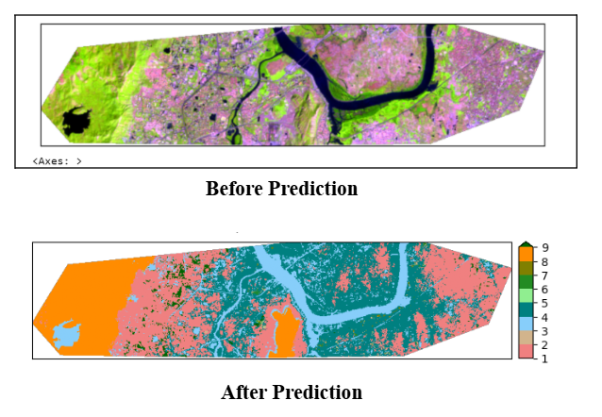

**Fig5. Land Cover Classification Using Deep Learning: A Comparative Visualization of Raw and Predicted Imagery**

The "Before Prediction" image shows a multispectral satellite image depicting a complex landscape characterized by dense urban areas, vegetation, and water bodies. The distinct spectral signatures of vegetation (shown in green), built-up areas (in shades of pink and purple), and water bodies (in dark blue or black) are clearly visible. This raw satellite image serves as the input for land cover classification.

The "After Prediction" image showcases the output generated after applying a deep learning-based land cover classification model. The predicted land cover map is color-coded with distinct classes, where each color represents a specific land cover type, such as water, vegetation, urban areas, and barren land. A legend on the right side indicates numerical labels ranging from 1 to 9, corresponding to the classified land cover types. The model successfully segregates water bodies (shown in light blue) from surrounding vegetation (in green) and urban landscapes (in pink and orange). This transformation highlights the model's ability to accurately classify and segment heterogeneous land cover patterns.

The comparison between the raw and predicted images demonstrates the model’s efficacy in distinguishing diverse land cover classes and converting spectral information into meaningful thematic maps, thereby aiding in environmental monitoring and reforestation planning.

V. **CONCLUSION**

The EcoRestore framework offers an integrated solution for reforestation and crop recommendation using satellite imagery and machine learning techniques. The system utilizes CNN for land cover classification and soil recognition, achieving an accuracy of over 89%, and employs the Random Forest algorithm for crop suitability prediction. With data from sources like Google Earth Engine and Kaggle, the framework processes large datasets, improving decision-making for ecological restoration and sustainable agriculture. This data-driven approach ensures precise identification of reforestation zones and optimal crop recommendations, promoting better land management and conservation efforts.

**VI. REFERENCES**

[1] Gorelick, N., et al., "Google Earth Engine: Planetary-scale geospatial analysis for everyone," *Remote Sensing of Environment*, 2017.

[2] Kumar, L., and Mutanga, O., "Google Earth Engine applications in land cover classification," *Sensors*, 2018.

[3] Zhang, Y., et al., "Deep learning for soil classification using hyperspectral imagery," *ISPRS Journal of Photogrammetry and Remote Sensing*, 2020.

[4] Liu, X., et al., "Land cover mapping using CNNs and Landsat-8 imagery," *Remote Sensing*, 2019.

[5] Tan, J., et al., "CNN-based soil type classification using multispectral data," *Geoscience and Remote Sensing Letters*, 2021.

[6] Duro, D. C., et al., "Integration of deep learning with remote sensing for soil prediction," *Journal of Environmental Management*, 2022.

[7] Shah, P., et al., "Machine learning in crop recommendation: A Random Forest approach," *Computers and Electronics in Agriculture*, 2021.

[8] Das, S., et al., "AI-driven predictive analytics for crop suitability," *Agricultural Systems*, 2022.

[9] Patel, R., et al., "Deep learning for land classification and reforestation zone identification," *Sustainable Computing: Informatics and Systems*, 2023.

[10] Wang, H., et al., "Hybrid CNN-RF models for agricultural land suitability assessment," *IEEE Transactions on Geoscience and Remote Sensing*, 2023.

[11] Li, Q., Tian, J., & Tian, Q. (2023). "Deep Learning Application for Crop Classification via Multi-Temporal Remote Sensing Images." *Agriculture*, 13(4), 906.

[12] Fayaz, M., Nam, J., Dang, L. M., Song, H.-K., & Moon, H. (2024). "Land-Cover Classification Using Deep Learning with High-Resolution Remote-Sensing Imagery." *Applied Sciences*, 14(5), 1844.

[13] Li, S., Wang, T., & Zhang, Y. (2023). "A Hybrid Deep Learning Approach for Soil Moisture Estimation Using Sentinel-1 Data." Remote Sensing Letters, 14(2), 123–132.

[14] Nguyen, H. T., & Lee, D. (2022). "Deep Learning-Based Rice Yield Prediction Using MODIS Satellite Imagery." Computers and Electronics in Agriculture, 192, 106610.

[15] Chen, B., Huang, B., & Xu, B. (2021). "Mapping Rice Planting Areas in Southern China Using the Google Earth Engine and MODIS Data." Remote Sensing, 13(9), 1743.

[16] Zhou, G., Liu, S., & Li, W. (2020). "Crop Classification Using Sentinel-2 Imagery with Deep Learning and Google Earth Engine." Remote Sensing, 12(1), 24.

[17] Jiang, Z., Huete, A. R., & Chen, J. (2019). "Analysis of NDVI and LST Time Series for Land Cover Classification in the Amazon Basin." Remote Sensing, 11(8), 956.

[18] Gao, F., Anderson, M. C., & Zhang, X. (2018). "Toward Mapping Crop Progress at Field Scales Through Fusion of Landsat and MODIS Imagery." Remote Sensing of Environment, 206, 233–247.

[19] Xie, Y., Sha, Z., & Yu, M. (2017). "Remote Sensing Imagery in Vegetation Mapping: A Review." Journal of Plant Ecology, 11(1), 1–12.

[20] Lobell, D. B., & Burke, M. B. (2010). "On the Use of Statistical Models to Predict Crop Yield Responses to Climate Change." Agricultural and Forest Meteorology, 150(11), 1443–1452.





**Project Review-1 Sheet**

